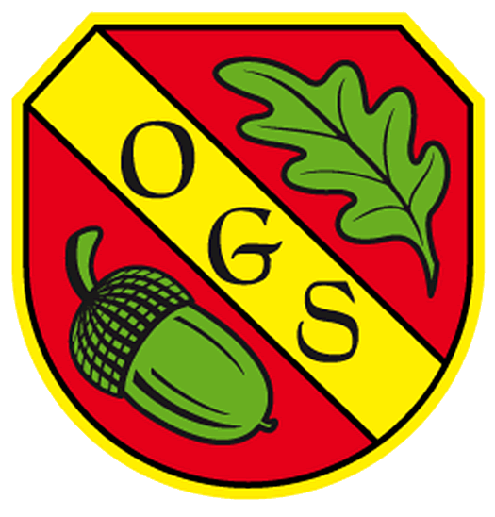

Oakhyrst Grange School
Menu – Autumn Term 2021
Menu  Week 1 | Week Commencing:- | Sample Menu | Subject to Change
Dish of Day | Monday | Tuesday | Wednesday | Thursday | Friday
 | Turkey Bolognaise served with Wholemeal Pasta and Seasonal Vegetables | Chicken Tagine served with Cous Cous and Seasonal Vegetables | Roast Pork, Roast Potatoes served with Stuffing Balls and Seasonal Vegetable and Gravy | Minced Beef and Thyme Pie with Puff Pastry Top served with Seasonal Vegetables and Potatoes | Baked Fish and Saute Potatoes with Seasonal Vegetables
Vegetarian Dish (only for who require this) | Tomato Penne Pasta | Quorn Tagine | Quorn Roast | Quorn Mince Pie and Pastry Top | Macaroni Cheese
Desert | Ice Cream | Sticky Toffee Pudding and Custard | Fresh Fruit Platter | Homemade Banoffee Pie | Homemade Flapjack
Fruit  Table | Fruit  Table | Fruit Table | Fruit  Table | Fruit  Table | Fruit Table

