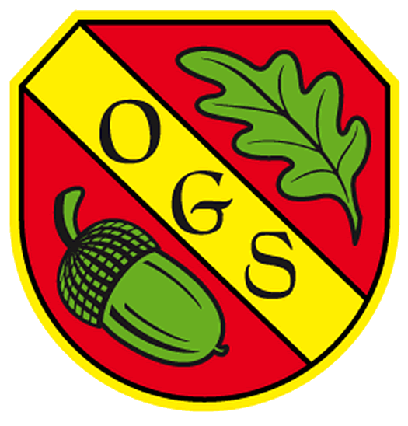

Oakhyrst Grange School
Menu – Autumn Term 2021
Menu  Week 2 | Week Commencing | Sample Menu | Subject to Change
Dish of Day | Monday | Tuesday | Wednesday | Thursday | Friday
 | Pork Sausage served with Mashed Potato, Onion Gravy and Seasonal Vegetables | Roast Garlic and Thyme Chicken Thighs with Cider Creamy Sauce served Wholemeal Pasta and Seasonal Vegetables | Roast Gammon, Roast Potatoes served with Seasonal Vegetables and Gravy | Chicken Korma Curry served with Wholemeal Rice and Naan Bread | Baked Fish served with Chips and Seasonal Vegetables
Vegetarian Dish (only for who require this) | Roast Cauliflower and Chickpea Casserole with Mint Yoghurt | Slow Cooked Creamy Quorn | Quorn Roast | Thai Green Tofu Curry | Pizza - Cheese & Tomato
Desert | Organic Yoghurts | Profiteroles with Chocolate Sauce | Fresh Fruit Platter | Homemade Key Lime Pie | Homemade Carrot Cake with Vanilla Frosting
Fruit  Table | Fruit  Table | Fruit  Table | Fruit  Table | Fruit  Table | Fruit Table

