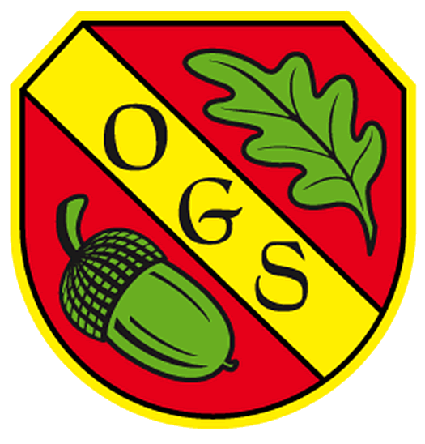

Oakhyrst Grange School
Menu – Autumn Term 2021
Menu  Week 3 | Week Commencing:-  13th September 2021
Dish of Day | Monday | Tuesday | Wednesday | Thursday | Friday
 | Sweet and Sour Pork Steaks with Steamed Rice and Seasonal Vegetables | Coq au Vin with Creamy Mash Potato served with Seasonal Vegetables | Beef Bourguignon served with Seasonal Vegetables and Potatoes | Roast Chicken, Roast Potatoes, Yorkshire Pudding served with Seasonal Vegetables and Gravy | Baked Fish served with Chips and Seasonal Vegetables
Vegetarian Dish (only for who require this) | Quorn Tacos | Roasted Vegetables and Feta Cheese served with Orzo | Quorn Roast | Vegetable Fajitas | Tomato Pasta
Desert | Organic Yoghurts | Homemade Lemon Drizzle Cake | Fresh Fruit Platter | Homemade Peach Crumble and Custard | Fruit Smoothie
Fruit  Table | Fruit  Table | Fruit Table | Fruit  Table | Fruit  Table | Fruit Table

