

Friday, 16th January 2026

NOTES FROM MRS MITCHELL

Dear Parents,
It has been a wonderfully busy and buzzy start to the new term at Oakhyrst Grange, and it has been a joy to welcome the children back to school. Our recent INSET days were centred around the theme of Excellence – revisiting our school values, mission and aims – and set a positive, ambitious tone for the year ahead.
The first two weeks have certainly been action-packed. It was lovely to see so many parents at our information session on forthcoming residentials, and we were delighted to host an excellent workshop on PSHE and RSE, ensuring that parents feel informed, confident and supported in this important area of school life. My thanks to Mrs Akerman, Miss Allybacus, Miss Sumners and Mrs Dance for your support with these sessions.
Residential experiences play a vital role in a child’s personal development. Spending a short time away from home in a safe, nurturing environment helps children build independence, resilience and self-confidence. It encourages them to try new things, develop friendships, problem-solve and manage small challenges for themselves, all while being carefully supported by staff. These experiences often become some of the most memorable and transformative moments of their school life, helping children grow socially, emotionally and practically. Please do feel free to speak with trip leaders or myself to discuss any trips.
The children have clearly enjoyed being back with their friends and settling quickly into routines. In assemblies, my focus has been on setting goals and aspirations – encouraging everyone to reach for the stars – and reminding the children that mistakes are marvellous, as this is where the real magic of learning takes place. I would recommend two wonderful books: ‘The Boy, the Mole, the Fox and the Horse’ by Charlie Mackesy – a very special book full of wisdom and kindness – and ‘You Are Awesome’ by Matthew Syed, which is packed with practical tips to build confidence and resilience. Both are fantastic reads for children (and adults!). You may hear your son or daughter talking about Paddington and having a Personal Best Moment (a “PB” moment – P for Paddington and B for Bear!). We are celebrating these moments in school and you may even spot a few PB moments at home too!
This week, we have also been focusing on one of our school values – Taking Responsibility, particularly for our belongings and our environment. The children already know Archie the Acorn, who reminds us how responsibility helps us grow strong like the oak tree, and they have now met Foxy, who is brilliant at filing everything away properly – from pencil cases and PE bags to wellies and coats!
Learning is well underway across the school: from exploring mountains in Year 4 to becoming science experts in Year 2, from swimming lessons to adventures in the Forest. A special well done to Kenji in Year 5 for taking the initiative to set up a new Puzzles and Strategies drop-in club – a wonderful example of leadership and creativity. Congratulations also to our Year 6 pupils who are entering a busy period of entrance exams and interviews; we are very proud of you. My thanks to Mrs Armstrong, our Education and Welfare Governor, for meeting with the pupils.
Thank you to the parents who have been helping at the morning gate in the icy and cold conditions, and to everyone for ensuring children are wrapped up warmly – your support is much appreciated. Congratulations too to our new School Council representatives, Eco Monitors and Wellbeing Ambassadors.
Class | Form | Vice | Eco | Wellbeing Ambassador
5 | Pareesa | Barney | Paige | Ophelia
4 | Harrison | Cara | Isabelle | Scarlett
3 | Arno | Kai | Joe | Emmy
2 | Georgina | Manny | Georgie | Oscar
1 | Archie | Maisie | Aidan | Louis
On Wednesday, I attended the Independent Schools Association (ISA) Conference, which brought together Heads from a wide range of independent schools, all united in their commitment to delivering educational excellence. The conference celebrated innovation, high standards, integrity and the importance of meeting the individual needs of every child through high-quality, personalised education and rich extra-curricular opportunities. It was also a pleasure to hear from Julia Robinson, President of the Independent Schools Council, who spoke inspiringly about the exciting future of independent schools.
The safety of our children is always our highest priority, and I would like to remind families to take extra care in the car park, particularly at pick-up time. We are pleased to confirm that a member of staff will now be supervising during these busy periods. In addition, investment will be taking place to repair and improve the entry speed bump. I appreciate your patience and cooperation while this essential work is carried out.
We have a wonderfully busy term ahead! The staff and I are looking forward to sharing many special moments with all of our boys and girls.
Have a lovely weekend.
Mrs Mitchell
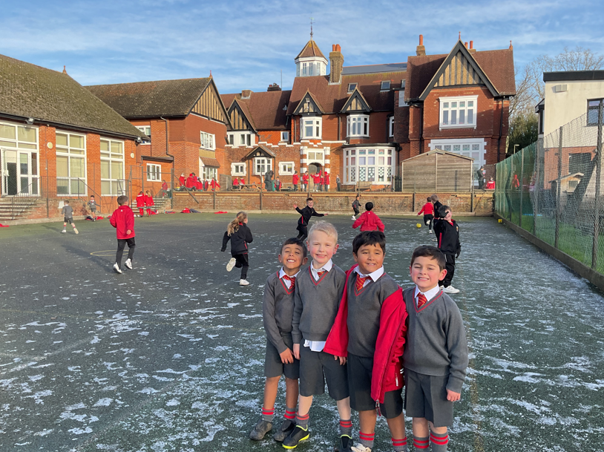

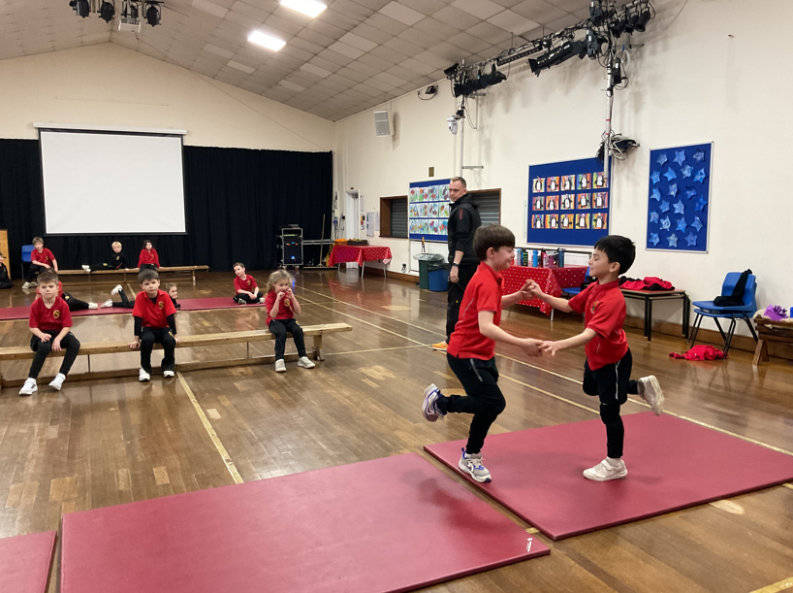 | 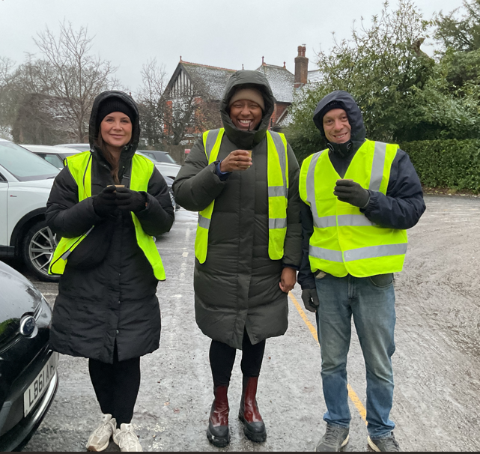 | 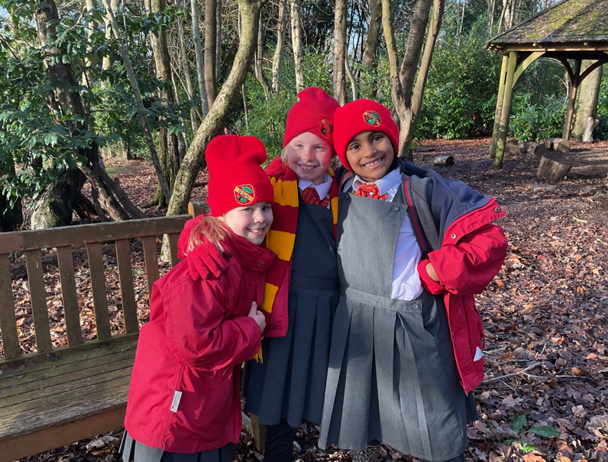
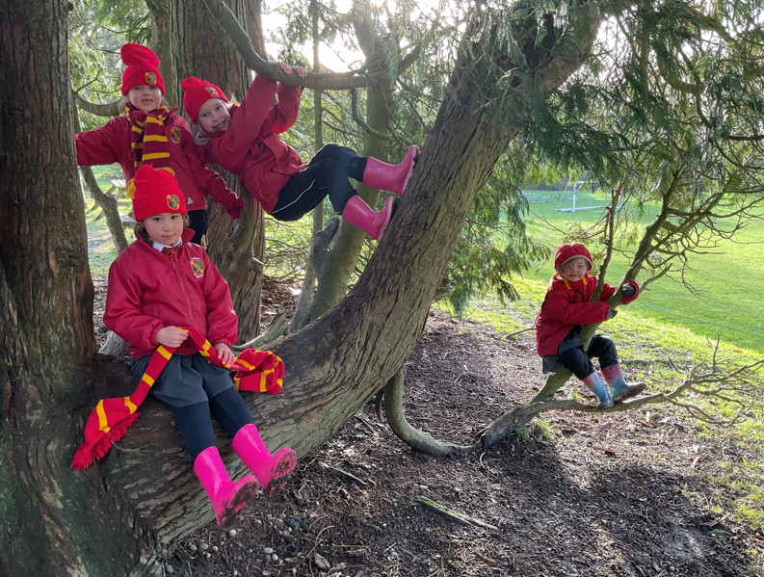 | 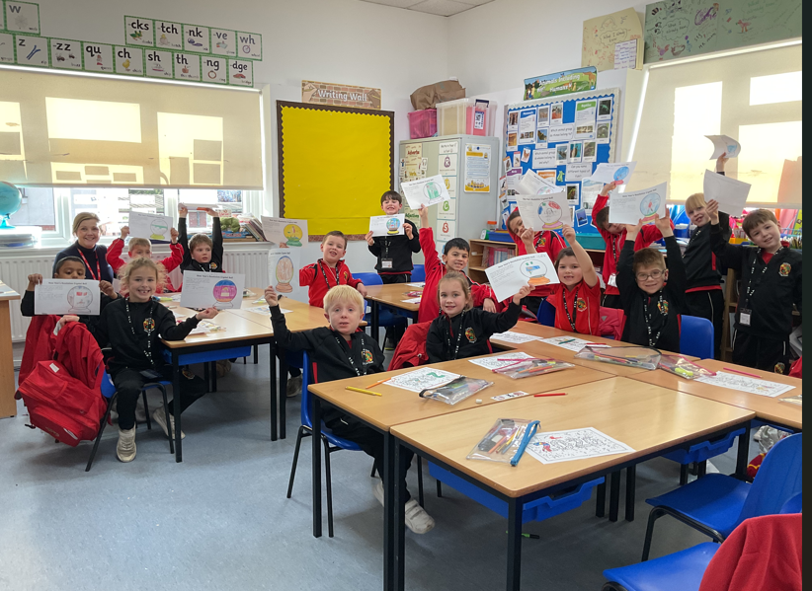 | 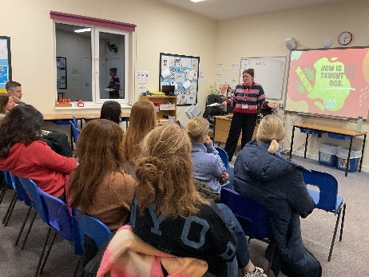
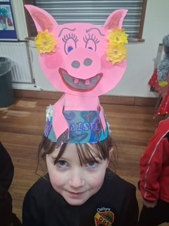 | 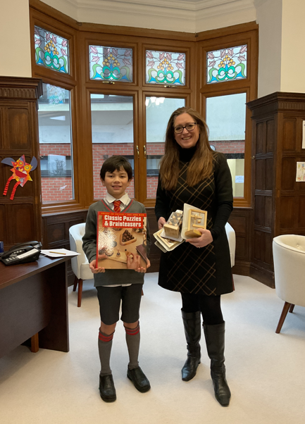 | 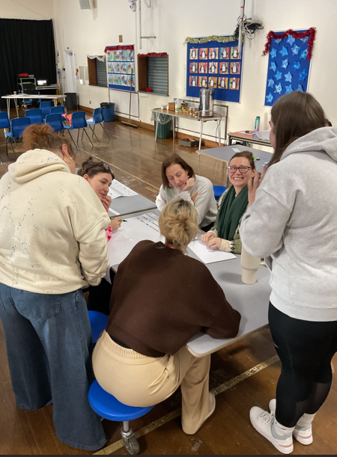
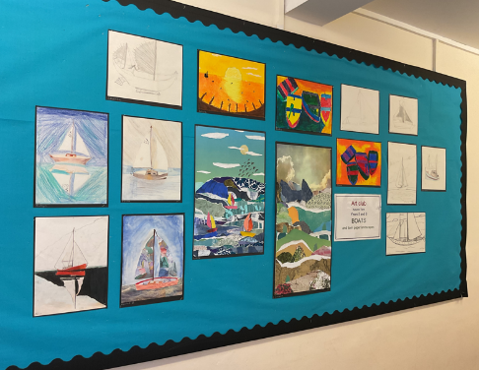 | 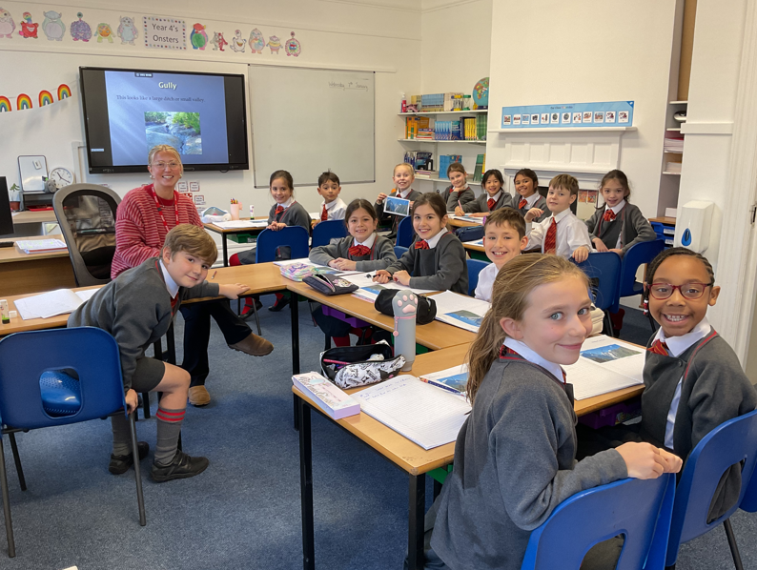 | 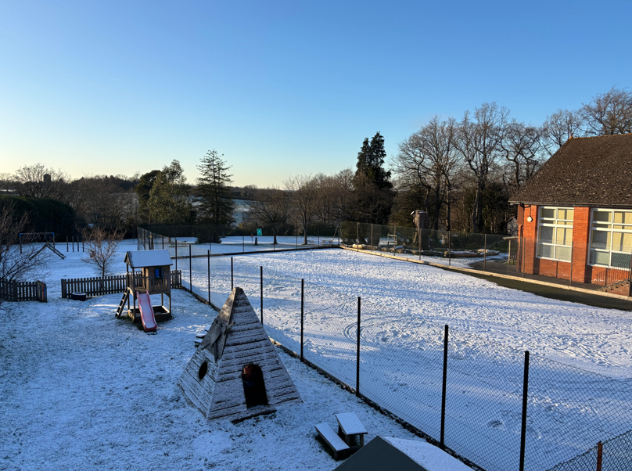
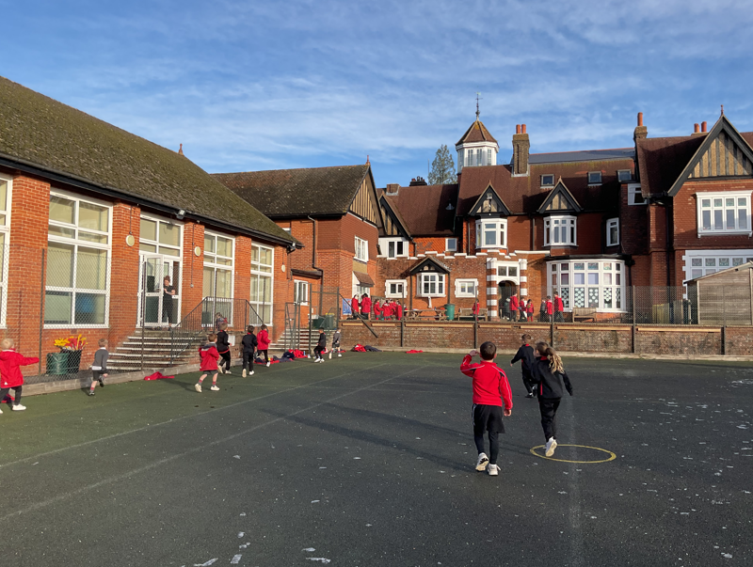 | 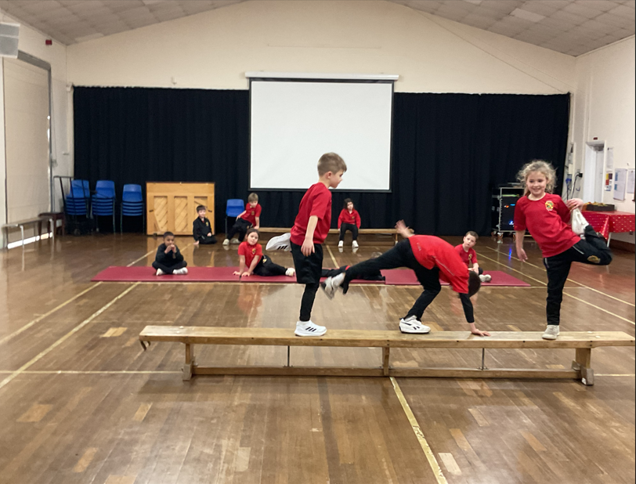 | 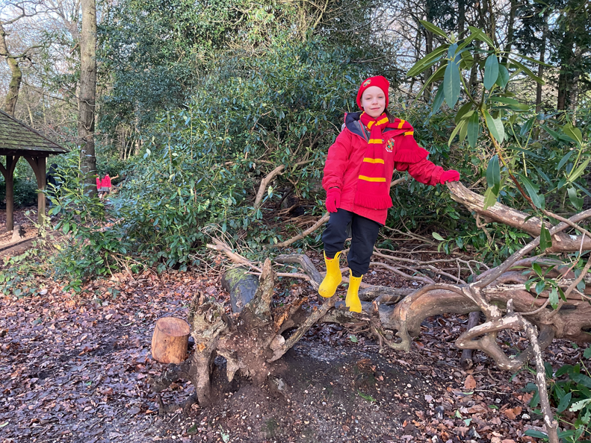
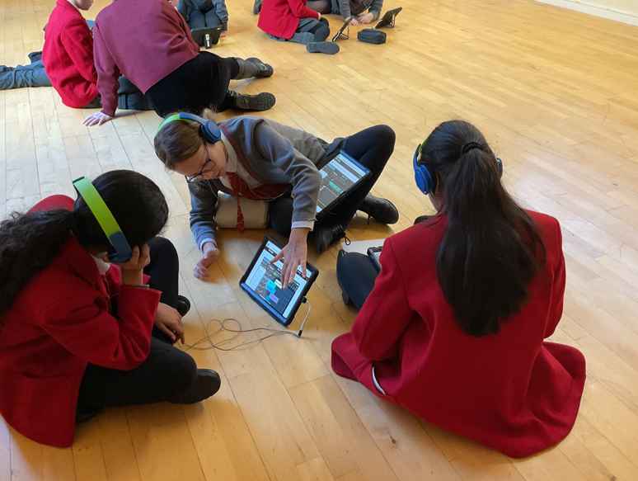 | 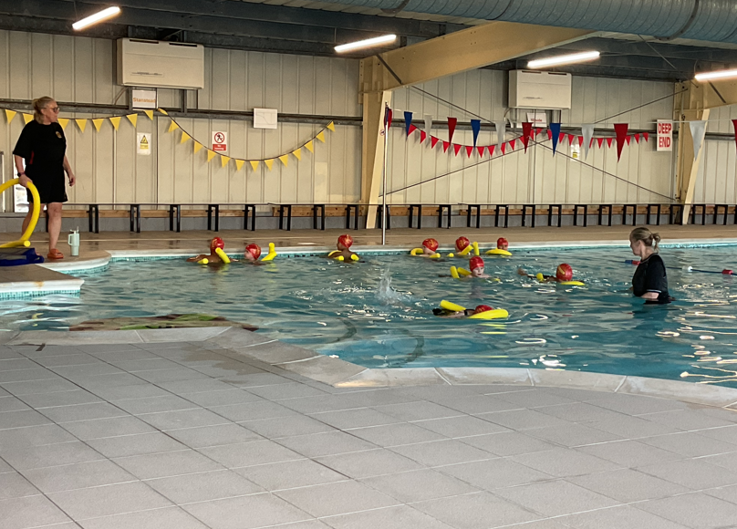 | 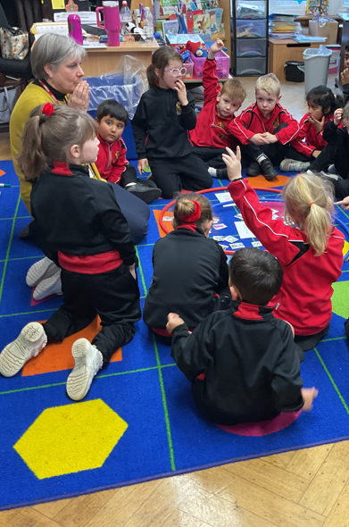
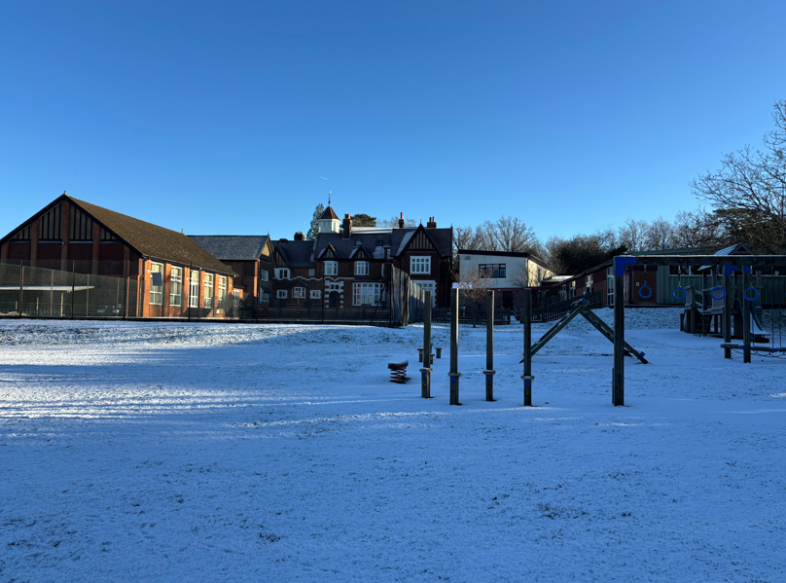 | 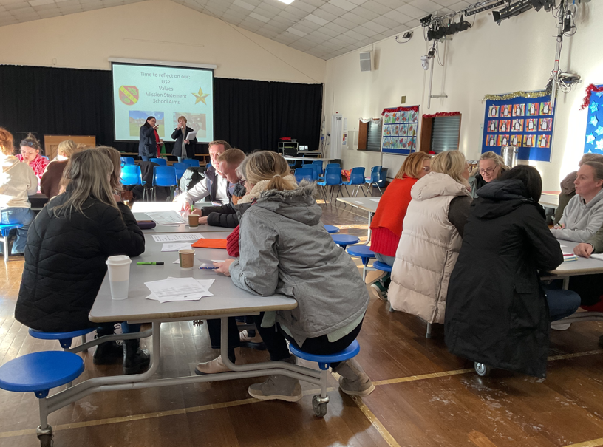 | 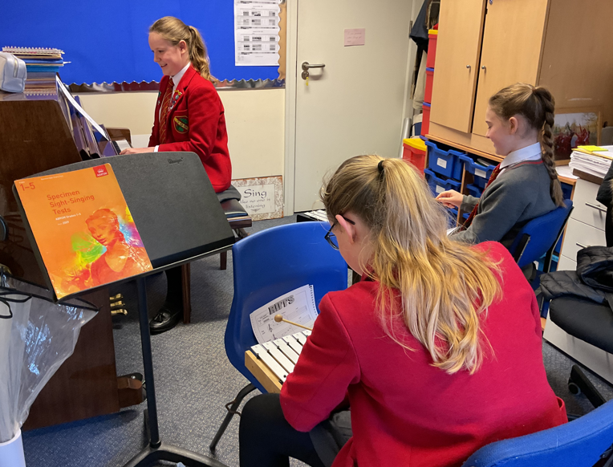
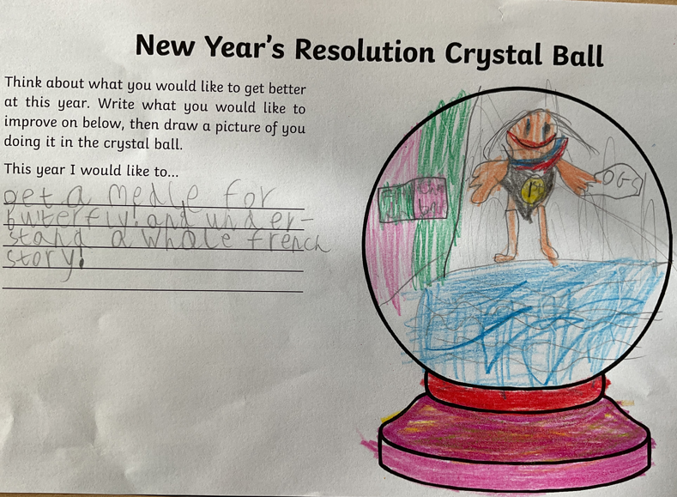 | 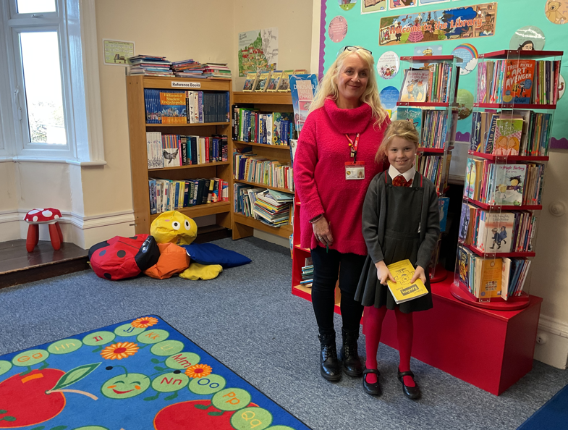 | 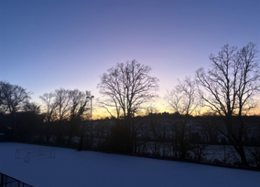
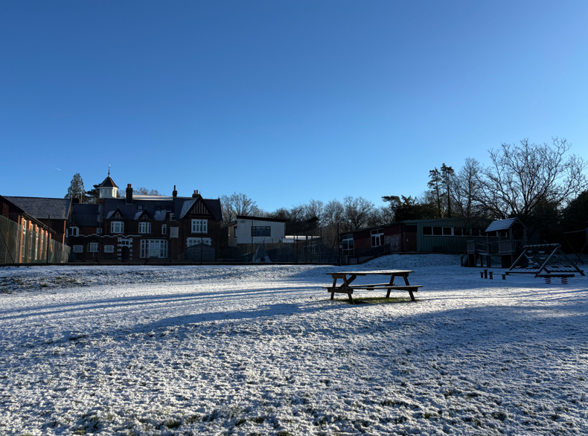 | 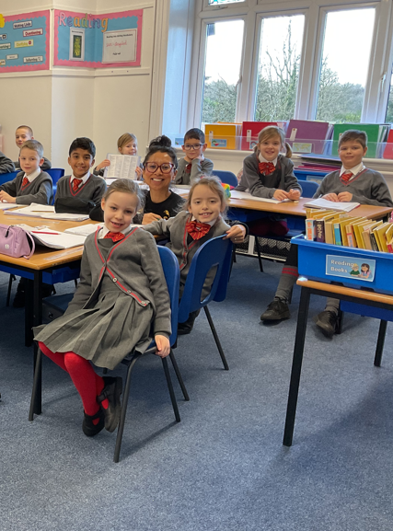 | 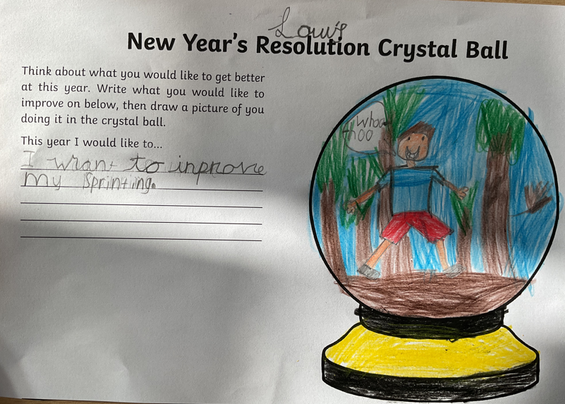
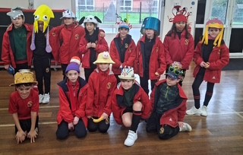 | 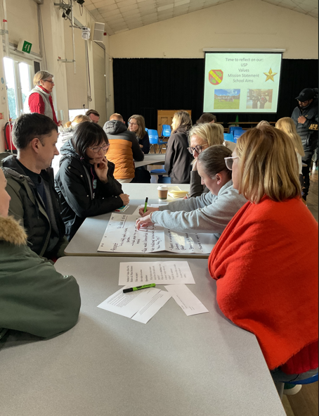 | 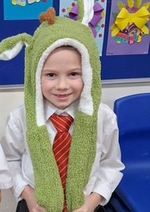

NOTES FROM THE EXCEPTIONAL OAKHYRST STAFF

Pre Reception

We have hit the ground running in Pre Reception with our first topic, Winter. We had a whole class discussion about what we already know about winter. We are looking at ice and how it melts, counting with snowmen and talking about what clothes we need to wear depending on the weather. We are also continuing our phonics learning with 3 new sounds! We also have had an impromptu Kpop party as requested by some of the children. We were really showing off our abilities for keep to the beat.
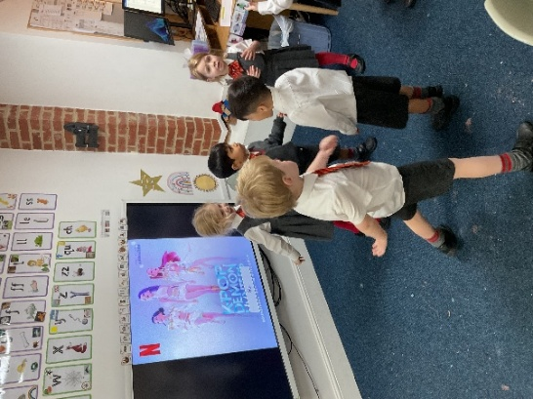
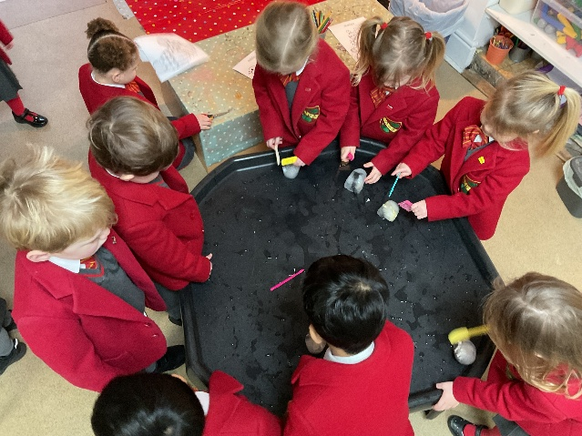

Reception
This week, Reception have crashed into the prehistoric era as we began our exciting dinosaur topic! The children have been fully immersed in all things dino and have shown brilliant curiosity and enthusiasm.
In Maths, we’ve been using dinosaurs to support our practical addition skills, counting, combining groups, and solving simple number problems through hands-on play. In literacy, the children have been busy writing their own dinosaur factsheets, sharing what they know using pictures, labels, and early sentences.
Our expressive arts and design sessions have been full of creativity as we experimented with dinosaur paint patterns, exploring colour, texture, and movement.
We’ve also been learning about a real-life dinosaur hero, Mary Anning, by reading her ‘Little People, Big Dreams’ book. The children were fascinated to discover her important role as a fossil hunter and scientist. Inspired by her work, we even carried out our own sand and dinosaur excavation in the classroom, carefully digging and uncovering hidden treasures like true palaeontologists!
We’re already so excited to continue our dinosaur learning journey next week and see where it takes us next.
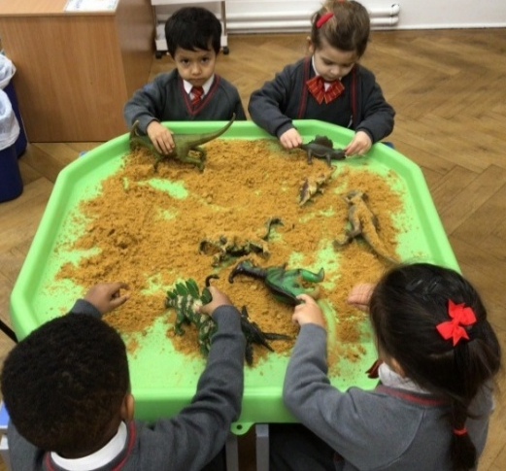
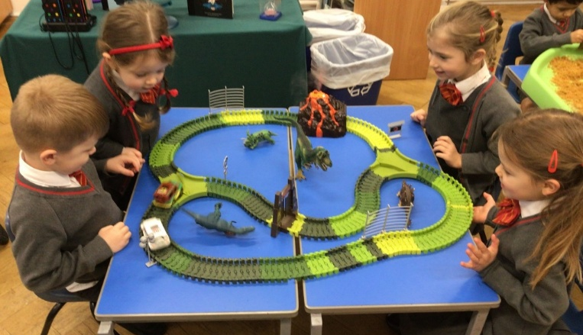

Year 1
The boys and girls have settled in extremely well and very quickly, showing a positive attitude to learning and a real eagerness to get started with our new topics.
In Geography, we are excited to begin our new topic, “The UK”. The children will be learning all about the home countries, exploring their names, locations and key features. This is already generating lots of interest and discussion in class.
In English, we have made a strong start on using full stops correctly to create more than one sentence. The children are beginning to understand how sentences work, and there will be plenty of opportunities to practise this skill over the coming weeks.
Our Digital Learning sessions have focused on using Scratch Jr. The children have enjoyed recording sounds, creating sprites and learning how to bring their ideas to life through simple coding.
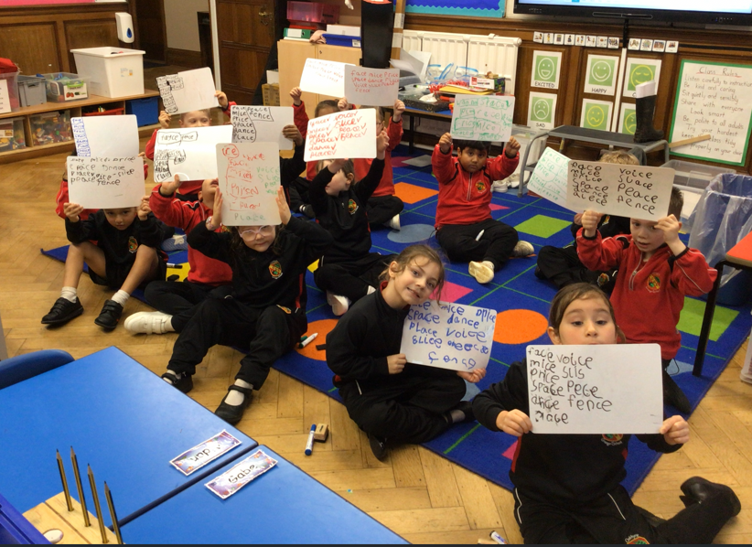
In Maths, our focus has been on money, learning about the value of coins, making different amounts and finding change. We have also begun looking at continuing simple shape and colour patterns, helping the children to recognise and predict patterns.
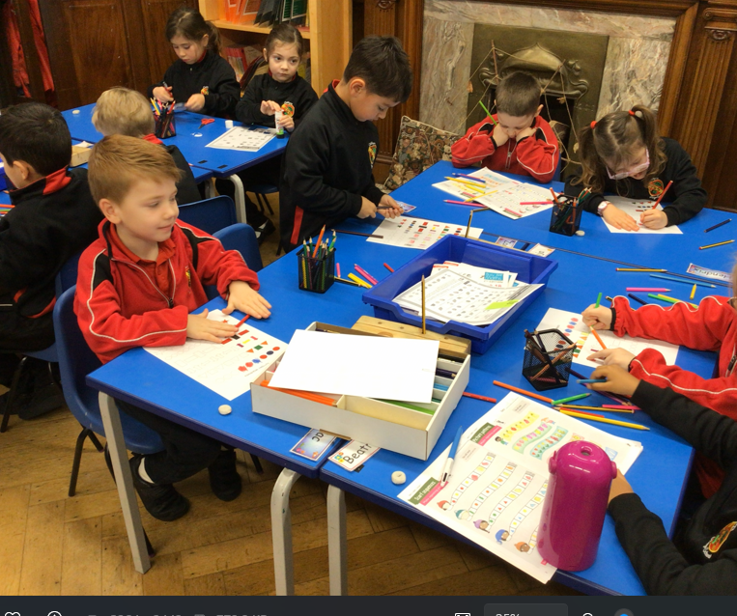

Year 2

We love Science in Year 2 and last term loved learning all about "Animals including humans" and celebrated our learning with our assembly.

This term, we started with a new topic "Materials and their uses" exploring different types of materials, where we should use them and why they were so good at their job! We have learnt lots of new vocabulary and were super science investigators finding out about the properties of materials.

We are moving onto learning all about “Living Things” now and will be going on a treasure hunt around the school!

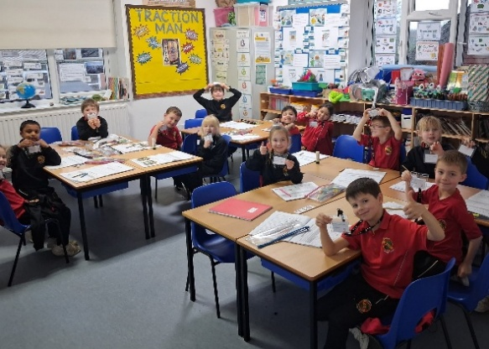
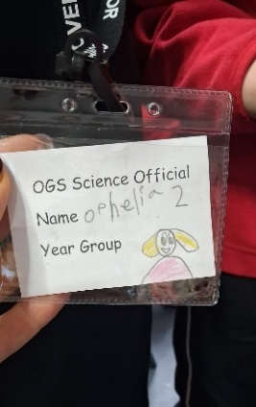
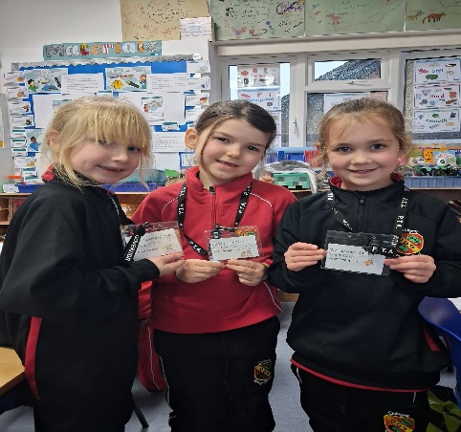

Year 3

A new half term, a new half term of learning! Year 3 have started to explore some exciting topics that link together across different subjects.
- Science - Forces and Magnets: Children will be discovering how pushes, pulls, and magnetic forces work in everyday life. They’ll get hands-on with experiments to see these forces in action.
- Geography - Extreme Earth: From volcanoes to earthquakes and tsunamis, we’ll explore the incredible power of nature and what happens when the Earth shows its strength!
- English - ‘Escape from Pompeii’: Through this historical fiction dramatic story, pupils will imagine life in Pompeii during the eruption of Mount Vesuvius. They’ll write their own vivid descriptions and bring history to life.
By connecting these subjects, the children will see how science explains the forces behind natural disasters, geography shows where and why they happen, and English helps them tell the story. It’s going to be an explosive half term of learning!
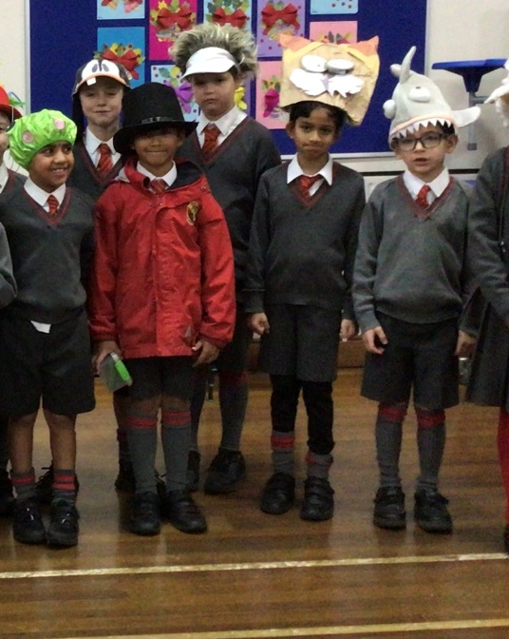
Silly Hat Day!

Year 4
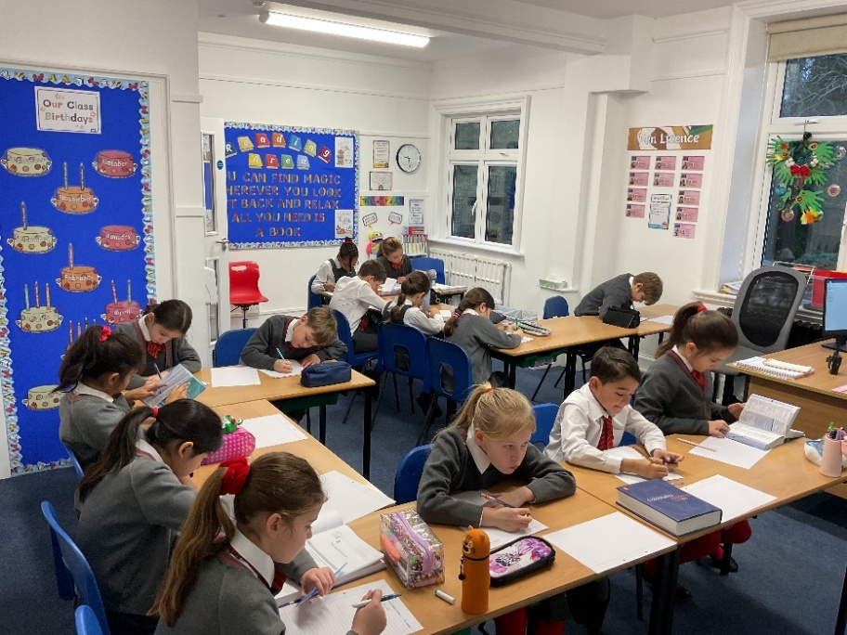
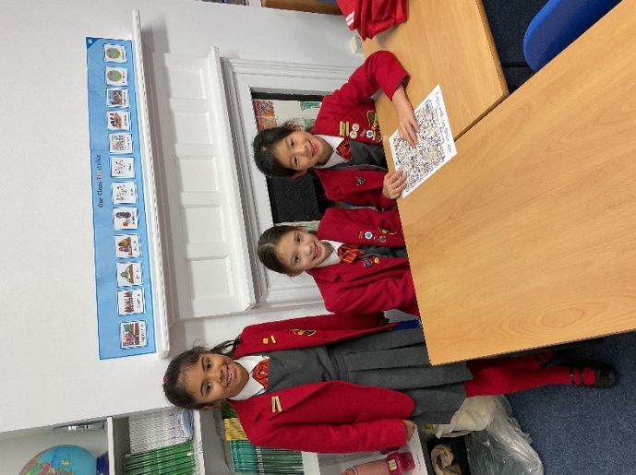
Year 4 have returned to school after the Christmas break full of energy and enthusiasm, ready for an exciting new term of learning. In Maths, we have jumped straight into fractions, where the children have been comparing different fractions of amounts and confidently debating which they would prefer. Lively discussions have taken place around questions such as whether 1/3 of £180 or 3/5 of £100 is the better deal, with pupils keen to justify their reasoning and challenge one another’s thinking.
In English, we have begun our new class book Stig of the Dump, which has already captured the children’s imaginations. The pupils have been writing recounts of their Christmas holidays, sharing all their exciting and fun stories. It has been wonderful to see how independently they are now using thesauruses and dictionaries, which is really excelling their writing and helping them to choose ambitious vocabulary. Believe it or not, class assembly rehearsals have also begun! The children are already hard at work, so get ready for another West End–worthy performance coming your way soon.

Year 5

Year 5 have made a brilliant start to the new school year and are as eager and determined as ever to develop, broaden and strengthen their skills and knowledge across the curriculum.

Within our English lessons, we have now finished our first-class reader text of the year, ‘Why the Whales Came’ by Michael Morpurgo which has kept us engaged throughout and we thoroughly recommend to other pupils of similar age. We have also begun our new text which is In Deep Dark Wood by Marita Colon-McKenna. We have made predictions based only on the images on the front cover and await to see whether these come to life.

Our Maths topics this term focus on fractions, decimals and percentages whilst our Science work focuses upon Structures and Materials. Both subjects will be full of practical investigations and experiments to enable us to test our knowledge and develop our understanding of key concepts and ideas.

Last Friday, we started our new Digital Learning topic of cryptography. We are excited at the prospect of learning more about communicating information securely through investigating early methods of communication over distances and learning different types of ciphers. Through this unit of study, we will also create links to Maths, History, PSHE and Science.

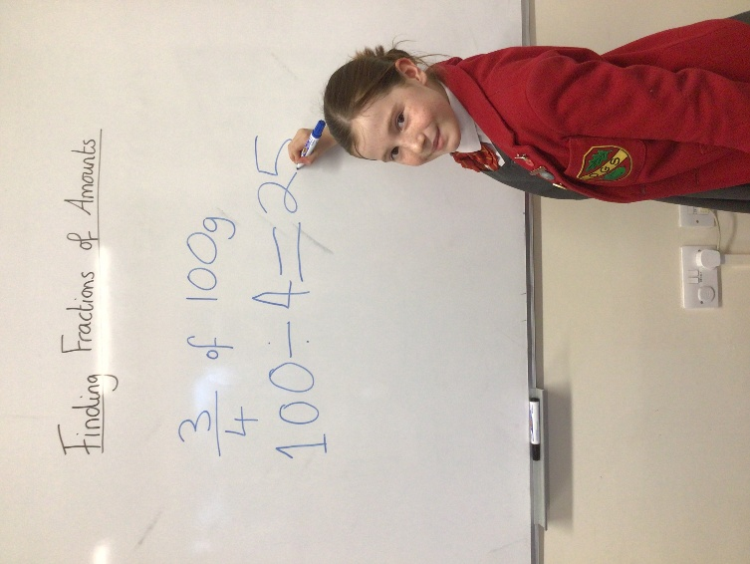
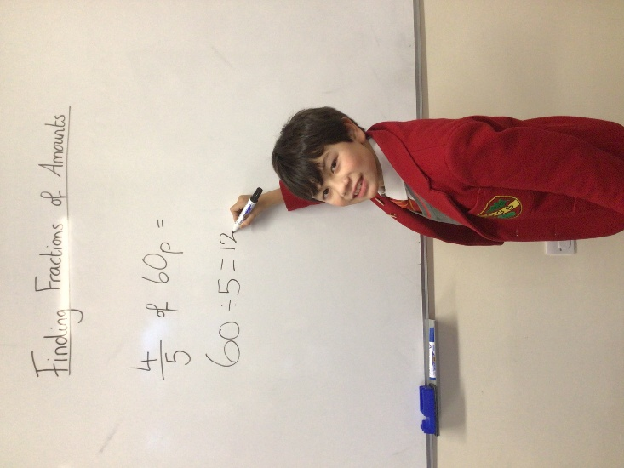

Year 6

This week, pupils have been engaged in a wide range of learning across the curriculum.

In Mathematics, the children have explored ratio and proportion, learning about the differences between them as well as understanding means and extremes. They applied this knowledge by adjusting recipes to ensure correct ratios.

In English, pupils have been working on the ISA Poetry Competition, linking their writing to our history topic on World War I. They examined WWI artefacts, including a brodie helmet, ration book and a post card from a loved one. The children wrote poems that tell the story of a day during the war from the perspective of these objects. As part of their reading comprehension work, pupils analysed free verse poetry and studied the effectiveness of storytelling through an object. The children completing a carousel activity, where they used clues to guess the poem. This learning was further supported in computing lessons, where pupils researched WWI trenches, exploring their construction and producing labelled diagrams.

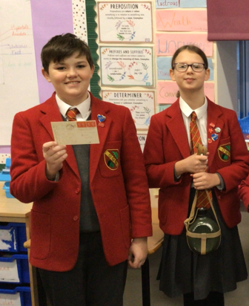

Sport
Welcome back to a new term of sport! We have been greeted with some very frosty mornings and icy conditions, but that certainly hasn’t stopped us beginning our Spring term with smiling faces.
Hockey (despite chilly conditions) has been in full swing during games lessons. Children have shown great determination in learning what might be a lot of new skills during these hockey lessons. We look forward to this progressing further.
Reminder – Year 3 – 6 children MUST have a gum shield & shin-pads.
In PE lessons, Gymnastics has been a focus across the school. Pupils have been developing their balance, strength and flexibility, while demonstrating excellent concentration and resilience as they learn and refine new skills.
There are also lots of exciting competitions coming up this term, from ISA events to cross-country events within school. We look forward to seeing our children represent the school and give it their best effort.

Well done to all swimmers who took part in the relay swimming gala against Royal Russell on Tuesday. It was a fantastic event, and the swimmers should be very proud of their performances and the way they represented the school. A big thank you to Mrs Evans for her continuous hard work. It’s great to have Mrs Harris as part of our Sports Department now and I know she loved her first OGS gala!
Mr Smith & Miss Lomax

ART GALLERY

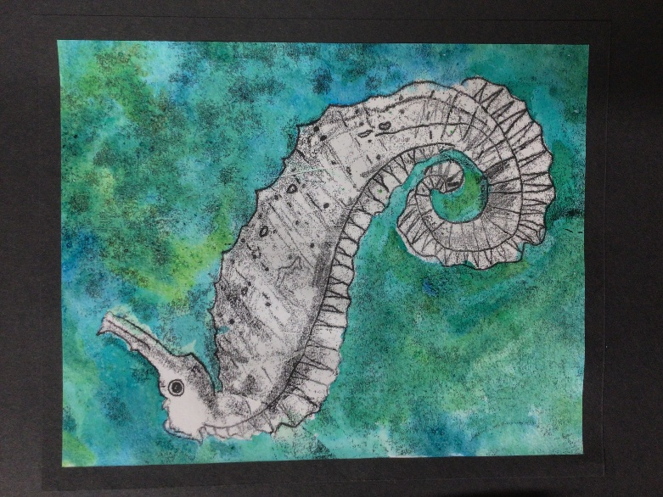
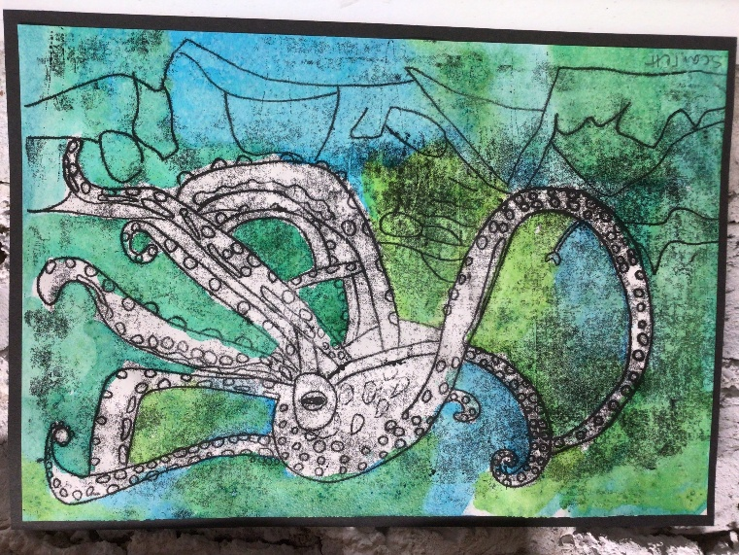

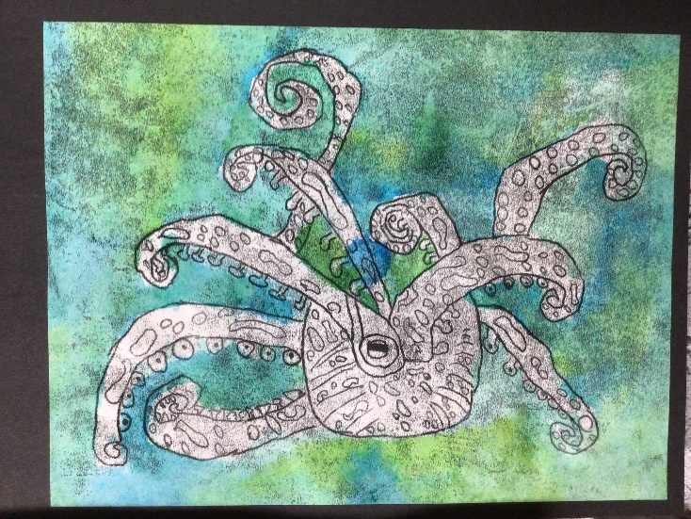

Sea creatures by Isabelle, Scarlett and Isla, Year 4.

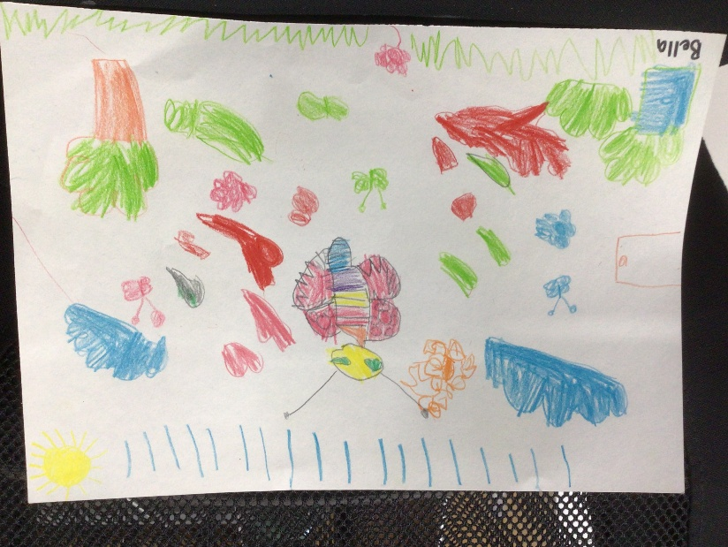

Butterfly by Bella, Pre-Reception class.

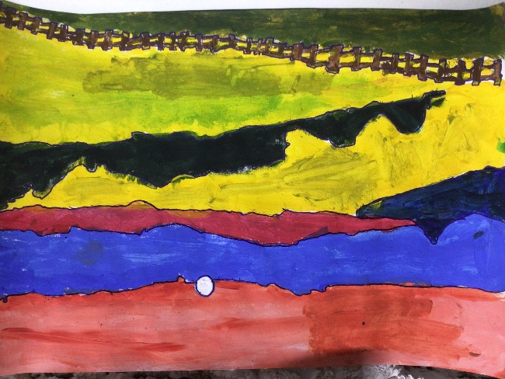
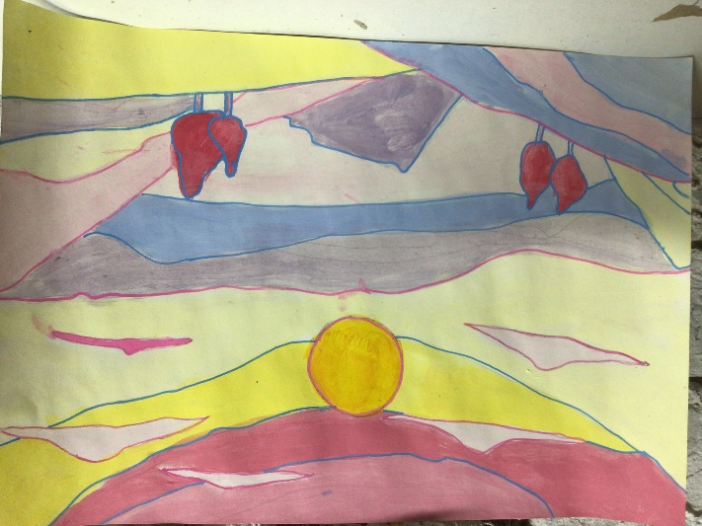
Landscapes by Sienna and Brandon, Year 6.

Music
We have had a great start to the year in Music across the school. Year 6 are focusing on composition this term, using the digital music platform Charanga. The children are learning about music production, how to structure songs, add layers, and develop their own musical ideas. Pupils can also access Charanga at home with a password and, with a signed permission form, can continue working on projects and assignments set in class.
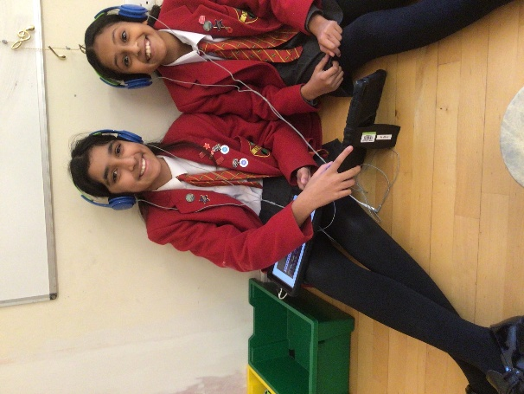
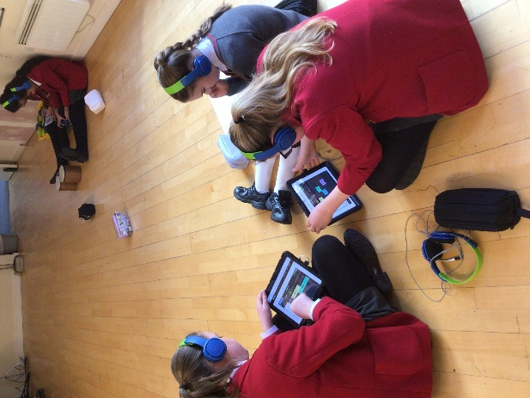

In the younger years, Reception and Year 1 are busy learning songs for their upcoming class assemblies, with themes including Dinosaurs and the Countries of England. Linking music with other subjects is always valuable, as it reinforces learning in a fun and creative way. Year 2 have been learning a song about the seven continents, while Year 3 have learned a song about the Romans and are navigating their way through music inspired by deserts, again closely linked to their learning this term. Year 4 are learning about the Vikings and are preparing songs for their class assembly, as well as learning a song about rivers for their class concert, linking closely with their classroom topics.
Year 5 are exploring music from the time of the Stuarts. This week, they learned a psalm that may have been sung by Cromwell’s soldiers as they prepared for battle, as well as successfully singing a five-part round that could have been enjoyed around a campfire at the end of the day.
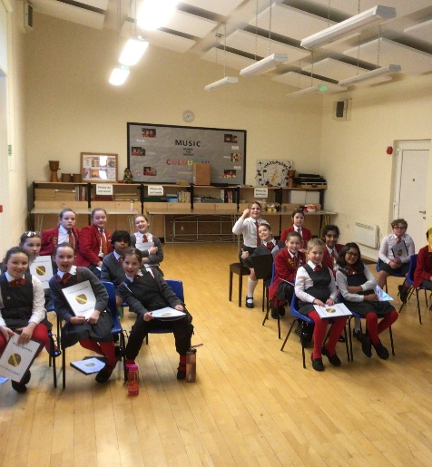
Our Chamber Choir have also had a brilliant start to the term and have begun learning a three-part song, and I am really looking forward to seeing how far they progress.
We are also looking forward to the Spring Concert later this term, which will involve some or all of our ensemble groups alongside our more experienced musical performers. Our amazing peripatetic teachers have had a great start to the week and, from what I hear, the children are making excellent progress. They will be working with their pupils in due course to prepare for this event — keep up the good work!

OTHER NEWS

School Council’s Silly Hat Day
The School was bursting with colour, creativity and laughter as pupils and staff took part in our fantastic Silly Hat Day, organised by our School Council on Thursday.
Children arrived wearing an amazing variety of imaginative and wacky hats! A special highlight of the day was the Silly Hat Parade, where pupils (and teachers!) had the opportunity to showcase their designs and celebrate each other’s creativity in true Oakhyrst Grange style.
Pupils were invited to donate £1 per hat, with all funds raised supporting the School Council’s sustainable garden project. This meaningful initiative highlights our commitment to environmental care and encourages pupils to play an active role in making a positive difference within our school community.
Well done to the School Council for organising such a fun and meaningful event, and thank you to everyone who took part and supported the cause!
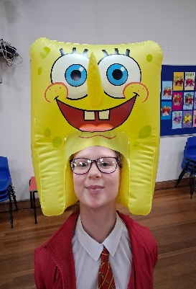
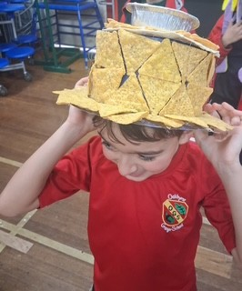
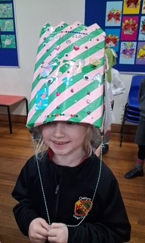
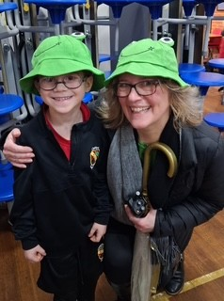

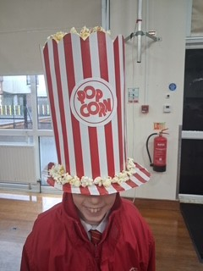

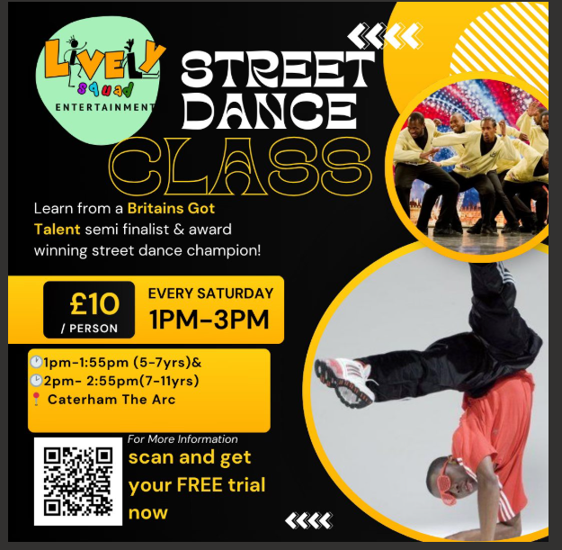
Sstreet Dance

ROTATIONAL WEEKLY MENUS
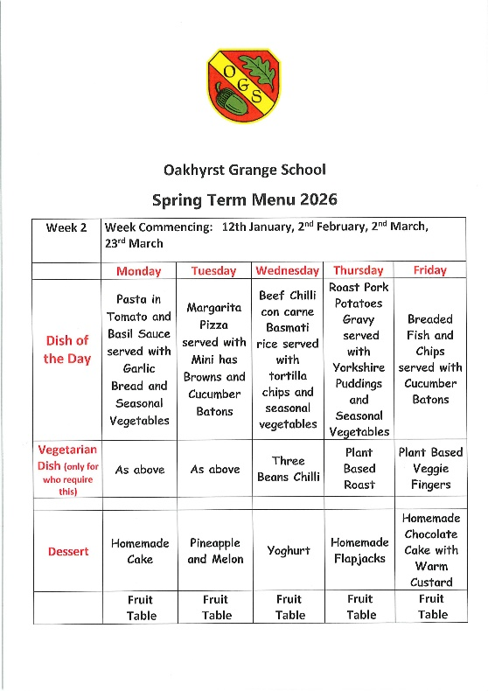
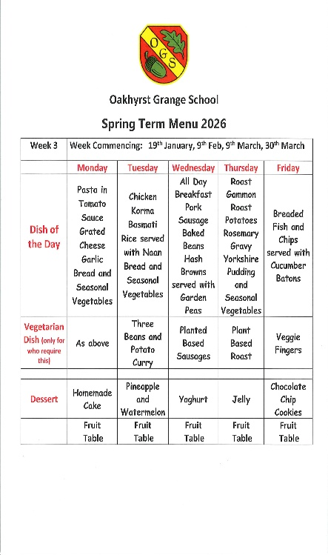
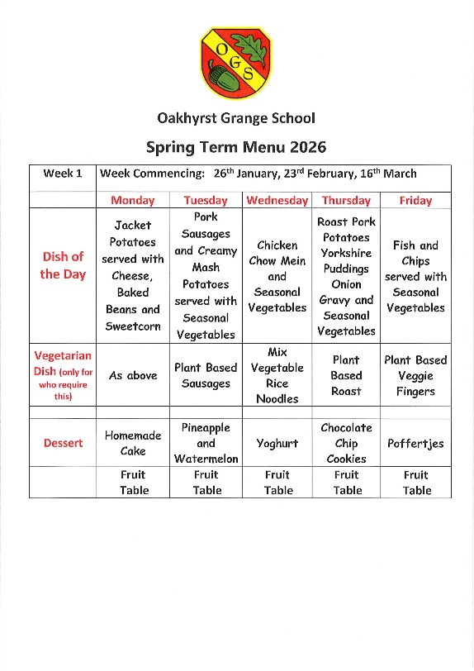
KEY FORTNIGHTLY DATES

- Monday 19.1.26 – Perform Workshop Midnight in the Topshop for children in PR to Year 2 – am
- Monday 19.1.26 – Chelsea Football Coaching Sessions for Years 5 & 6 – pm
- Tuesday 20.1.26 – Taster Sessions with Llama Drama Club – R to Year 2 – 1.10pm, Years 3 to 6 – 1.35pm
- Wednesday 21.1.26 – Wellbeing Wednesday – no homework today
- Wednesday 21.1.26 – Year 3 Parents Come and Learn session – Year 3 classroom - 9.05am to 9.40am
- Friday 23.1.26 – Top table lunch with Mrs Mitchell
- Monday 26.1.26 – Selected Years 1 and 2 cross country competition hosted at OGS – 1.30pm
- Tuesday 27.1.26 – Selected pupils attending Epsom College Strings Day – all day
- Wednesday 28.1.26 – U11 Girls Hockey fixture v Aberdour School – away – leave OGS 1.15pm
- Thursday 29.1.26 – U11 ISA Boys’ Hockey Competition – away – Lee Valley Stadium – all day
- Friday 30.1.26 – U11 ISA Girls’ Netball Competition – away – Lingfield College – all day

