Risk Assessment Policy

Date Reviewed: | September 2025, November 2025, 05.06.2026
Next Review Date: | 05.06.2027
Policy Owner: | SLT/MB
Ratified: | Annually at Full Governing Board

Date | Amendment | Staff Member
05/06/2026 | Page 1 – policy owner – updated – RS name removed | MB

Mission Statement
We are committed to providing a supportive, enjoyable and family style environment in which every child is nurtured and encouraged to achieve their potential through a broad-based curriculum and opportunities for developing sporting, dramatic, artistic and musical talents.

Statement of Aims & Objectives
- To enable each child to fulfil their own academic and personal potential.
- To instil in every child the importance of developing personal initiative and to foster in them a belief that they can fulfil their potential in any area of school life.
- To provide a broad based academic and extra-curricular education that is delivered in such a way as to satisfy the learning needs of each and every pupil.
- To help each pupil to develop both a set of Christian values and an understanding and appreciation of other religious beliefs.
- To learn the difference between right and wrong and to appreciate that rights and responsibilities are equally balanced.
- To develop and promote a sense of caring and community between the pupils within the school and the wider community as a whole.
- To instil in each pupil a high degree of self-respect and respect for their fellow pupils, teachers and other adults.
- To prepare each child for the transition to the next stage of their education and to be able to take advantage of any opportunities as they present themselves.

Safeguarding
Oakhyrst Grange School is committed to safeguarding and promoting the welfare of children and young people and expects all staff and volunteers to share this commitment. At this school we respect and value all children and are committed to providing a caring, friendly and safe environment for our pupils so that they can learn in a relaxed and secure atmosphere. We believe that every pupil should be able to participate in all school activities in an enjoyable and safe environment and be protected from harm. This is the responsibility of every adult employed by, or invited to deliver services at Oakhyrst Grange School. We recognise our responsibility to safeguard all who access school and promote the welfare of all of our pupils by protecting them from physical, sexual and emotional abuse, neglect and bullying. This should be read in conjunction with the Safeguarding Policy.
All staff will be asked to complete training annually following KCSIE updates. Further safeguard training will take place throughout the year. All staff must wear their lanyards at all times.
The Safeguarding governor is: Pauline Clark Pauline.clark@oakhyrstgrangeschool.co.uk
DSL: Roxann Dowling (Head of EYFS)
DDSL: Gemma Mitchell (Headteacher)
DDSL: Faye Dance (Deputy Headteacher)
Telephone: 01883 343344
Safeguarding Team: DSL@oakhyrstgrangeschool.co.uk

RISK ASSESSMENT POLICY
1.1 Scope
In line with the School’s Risk Management Policy and the requirements of the Independent Schools Standards Regulations (ISSRs) 2014 and Early Years Foundations Stage, Oakhyrst Grange School’s (OGS) approach to Risk Assessment seeks to:
1.1.1 Ensure that major risks are identified and managed as part of our overarching policies to prioritise safeguarding and the welfare of our pupils.
1.1.2 Meet the ISSR requirement for a written risk assessment policy to be in place and to meet the requirement for leadership in and management of schools.
1.1.3 Ensure the requirements of Health and Safety at Work Legislation are met
1.1.4 Ensure that suitable and sufficient risk assessments are undertaken for activities where there is likely to be significant risk including school trips
1.1.5 Ensure that identified control measures are implemented to control risk so far as reasonably practicable.
1.1.6 Ensure that those affected by school activities have received suitable information on what to do.
1.1.7 To identify those in the school responsible for conducting risk assessment and monitoring its implementation.
1.2 Governance
1.2.1 The Governing Body including the Head Teacher and Governors are responsible for the overarching risk management policy of the school. OGS’s Risk Management Policy is formally reviewed on an annual basis.
1.2.2 The Risk Management Policy references OGS’s approach to Risk, OGS’s Risk Register (known as Board Risk Management Matrix) and Planned Preventative Maintenance document (PPM).
1.2.3 OGS’s Board Risk Management Matrix will be reviewed regularly throughout each academic year by the Health and Safety Committee, and reported through to Full Governance Board.
1.2.4 The Risk Assessment Policy focuses on those risks identified in regard to the Health, Safety and Wellbeing of pupils and staff. These risks include, but are not limited to:

(a) pupil supervision (including safeguarding and welfare requirements). This will include implementation of the School’s designated safeguarding lead ("DSL"), but will also cover a range of responsibilities outside safeguarding
(b) school trips
(c) management of visitors on school premises
(d) fire and emergencies
(e) traffic and pedestrian interaction on site
(f) management of hazardous substances
(g) use of hazardous equipment e.g. in DT, Art etc
(h) legionella
(i) asbestos
(j) the suitability of staff to undertake designated roles and checks to ensure that they are suitable including staff not employed by the school who work with pupils on another site
(k) further risk areas which are not directly related to health and safety, include but not limited to:
(i) financial, legal/regulatory compliance
(ii) Teaching/Administrative resources/Accommodation
(iii) Governance/reputational
(iv) critical incident/terrorism, including the prevention of fundamentalism and extremism
(v) pupil self-harming
(vi) security, specifically EYFS areas or as appropriate
1.2.5 This risk assessment policy controls major risks identified in regard to the health, safety and wellbeing of pupils and staff, with procedures for risk assessment, including:
(a) when to complete risk assessments
(b) who is responsible for drafting and checking
(c) records to be kept
(d) training requirements for staff

1.3 Implementation
1.3.1 The Bursar will be responsible for the implementation of the risk assessment policy. The policy is reviewed annually.
1.3.2 All staff will receive guidance on the school’s approach to risk assessment by the Bursar, as part of their induction. This is refreshed on an annual basis or as required. Risk assessment training is provided as necessary, where identified by the Bursar / Premises Manager.
1.3.3 A template risk assessment form has been developed and is appended at Appendix 1, and filed electronically for use on the shared drive. Risk assessments should be carried out as soon as an activity or event is planned, or where there have been changes to previous arrangements (point 1.3.8 below).
1.3.4 Each risk assessment is intended to take into account:
(a) hazard - something with the potential to cause harm
(b) risk - an evaluation of the likelihood of the hazard causing harm
(c) risk rating - assessment of the severity of the outcome of an event (which will be cross-referenced with the Risk Register)
(d) control measures - physical measures and procedures put in place to mitigate the risk

1.3.5 The risk assessment process that OGS have adopted consists of the following 6 steps:
(a) what could go wrong
(b) who might be harmed
(c) how likely is it to go wrong
(d) how serious would it be if it did
(e) what we will do to prevent it
(f) how we will check that our plans are working
1.3.6 Once assessments have been completed and where actions have been identified to mitigate risk that will have an impact on organisational, operational or financial matters, the requirements of the risk assessment will be brought to the attention of the SLT in order that necessary action can be taken.
1.3.7 The Bursar and Premises Manager will be responsible for the maintenance of risk assessment records. The Health & Safety Committee monitors risk on behalf of the Head Teacher and Governing Board, and will request sight of records on a regular basis to assure itself that this OGS’s Risk Assessment Policy is complied with.
1.3.8 Individual risk assessments will be reviewed:
(a) when there are changes to the activity
(b) after a near miss or accident
(c) when there are changes to the type of people involved in the activity
(d) when there are changes in good practice
(e) when there are legislative changes
(f) when an assessment may no longer be valid e.g. changes to operational practices or work activities
(g) annually if for no other reason

1.4 Further Guidance
1.4.1 Areas that may require a risk assessment are outlined in Appendix 2. This list is not exhaustive.
1.4.2 Further reading and guidance regarding the legal requirements and educational standards relating to Risk Assessment is referenced in Appendix 3.

This Policy is subject to regular review.

Appendix 1: Risk Assessment Template
Health and Safety Risk Assessment – Template

School |  | Assessment No.

Site |  |  |  |  | Location
Subject of Assessment

Assessed by |  |  |  | Date |  |  |  |  | Review date
Details of workplace/activity |  |  |  |  |  |  |  | Persons Affected  (Who may be harmed)
 |  |  |  |  |  |  |  | Students, Staff, Premises Team and visitors

Hazards and Risks |  | Risk Rating  (Very High, High, Medium, Low) | Existing Control Measures | Risk Level after Control Measures  (Very High, High, Medium, Low) | Further Actions  √/X  (If √ See Actions)
1.
2.
3.
4.
5.
6.
7.
8.
9.
10.
11.
12.
13.
14.

Please note:
The hazards and controls noted above are an example of that which may be present when completing such a task. This assessment template is an example only and should either be used as reference only or amended to reflect the actual hazards and controls identified on site by the assessor.

Following assessment if no further actions are assessed to be required, please mark an X in the “Further Actions” box. If, however additional controls or actions are assessed to be required please place a √ in the box and note the action in the action plan.

ACTION PLAN
(Additional Control Measures Required/Recommended Actions)

Hazards and Risks |  | Recommended Actions | Target Date | Completed by | Date Completed

Any further actions identified should be completed before the assessed task is carried out.

Reviewed / Approved By |  | Job Title |  | Date

By signing this risk assessment, I confirm the assessment has been shared / made available to all relevant staff to review. All staff have been asked to confirm they have read and understood the control measures.

Appendix 2: Assess the Level of Risk

In this risk assessment the level of risk is expressed qualitatively as Low, Medium, High or Very High. Underlying these descriptors of risk is a probabilistic model which factors the likelihood of an accident or event against the severity of harm that may occur. The risk rating, calculated as likelihood x severity, maps into the qualitative terms used as follows:
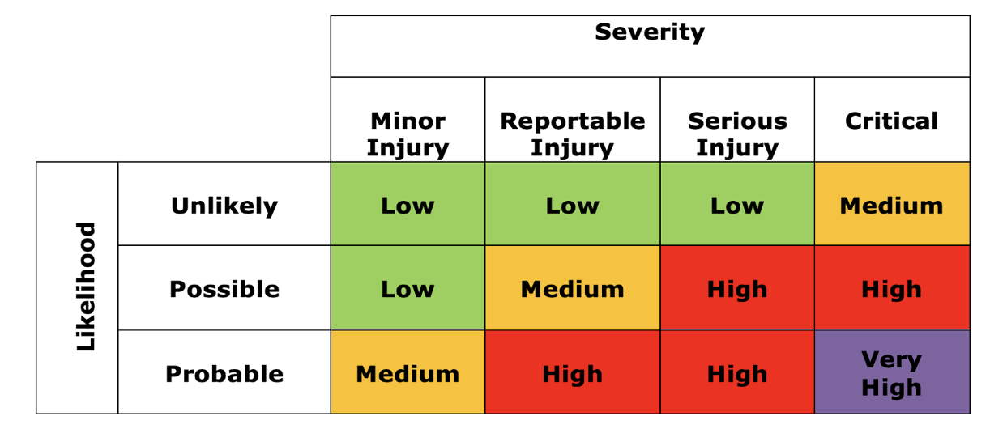

Reportable Injury is an important threshold and refers to UK legislation in this respect, often referred to as RIDDOR. A reportable injury or occurrence includes:
- major injuries as defined in RIDDOR,
- accidents that resulted in more than 7 days off work,
- an injury to member of the public, a customer or visitor, or a school pupil or student, that required hospital treatment.

(See https://www.hse.gov.uk/pubns/edis1.pdf for more information on RIDDOR).

Appendix 3: Areas requiring risk assessment (non-exhaustive)
- Educational
- science experiments
- design & technology
- food technology
- sport and PE activity
- art
- music
- drama & dance
- general classroom
- Forest School activities
- Pre and after school activities
- school trips
- Support – Designated leads with external advice where appropriate
- catering and cleaning
- caretaking and security
- legionella
- asbestos
- maintenance
- grounds / traffic management
- office
- site visitors
- fire & emergencies
- Pupil Safeguarding and Welfare

Legal Requirements & Education Standards
References:
A: Handbook for the Inspection of Schools - The Regulatory Requirements, Part 3 (http://www.isi.net/)
B: Health & Safety Executive, Five steps to risk assessment (http://www.hse.gov.uk//risk/fivesteps.htm)
C: Health and Safety Advice on Legal Duties and Powers for Local Authorities, Head Teachers, Staff and Governing Bodies (2014), DfE website.
D: Health and Safety at Work" Section H of the ISBA Model Staff Handbook,
E: "Health and Safety and Welfare at Work" Chapter N of the ISBA Bursar's Guide
F: "Insurance" Chapter K of the Bursar's Guide by HSBC Insurance Brokers Ltd
G: Early Years Foundation Stage: Statutory Framework
H: Charities and Risk Management, The Charities Commission (www.charity-commission.gov.uk)
I: Risk Management framework: A Ten Point plan and What is Risk Management by the NCVO (www.ncvo-vol.org.uk)
J: Home Office guidance on duties under the Counter Terrorism Act 2015 (www.gov.uk/government/publications/prevent-duty-guidance)

