

Friday, 16th October 2026

NOTES FROM MRS MITCHELL

There has been plenty of lively discussion at our School Council meetings especially when Steve, our chef, joined the children to hear their ideas for school lunches. From sushi to ‘Fajita Friday’, there were lots of suggestions—and plenty of requests for pudding! Thank you to Steve for listening and to our councillors for sharing their ideas so enthusiastically.
In my assemblies over the last few weeks, we have explored British Values, including democracy and the importance of mutual respect. We talked about identity and heritage, celebrating how our differences make each of us special and unique. The children also shared some of their future aspirations, from architects and interior designers to engineers and footballers. It was wonderful to hear their ambitions!
Last week, we focused on first aid, fire safety and road safety. The children were reminded about the trusted adults they can go to if they are worried or need help. We revisited our ‘five trusted adults’ approach, using the fingers on one hand to help them remember. You may wish to talk to your son or daughter about who their five trusted adults are.
Shelly the Turtle is now a very familiar character around the school, and last week the children also took part in a lockdown drill. This involves moving to a safe place within the school building and, if asked by a teacher, going into ‘Shelly Turtle Mode’—remaining calm and quiet and following instructions carefully. The children carried out the practice brilliantly, and our whole school community has now practised both a fire drill and a lockdown drill calmly and confidently.
On Monday, we marked World Mental Health Day by talking about the importance of connecting with others. Some of our playground buddies also took to the catwalk to model their playground buddy jackets. What a team!
Congratulations to everyone who has received Golden Leaves and Acorns this half term for embracing our school values. Larry, our school teddy bear who represents independence, has also begun his journey to Colombia with Mr Gonzalez to visit our international partner school, Escuela San Lorenzo. We look forward to following his adventures as the children learn more about the wider world.
We were also incredibly excited to officially open The Nook, our new wellbeing room. It was a pleasure to welcome Mrs Clark, our Chair of Governors, our PFOG Co-Chairs, Mrs Morgan-Robinson and Mrs Smith-Liggins, and our Wellbeing Ambassadors. A special well done to Aurelia, Bella (Y6) and Theo (Y5) for their beautifully spoken words, which helped make the occasion so special. We look forward to seeing The Nook become a welcoming space for our children to pause, talk and feel supported.
Our Grandparents’ Tea Party was filled with smiles, conversation and precious time together. Thank you to everyone who joined us and for your kind donations to PFOG, which raised £280 towards our wildlife garden!
Our Open Morning was a real success, with 11 prospective families enjoying a tour of Oakhyrst. A huge thank you to the Caterham Family grounds team for helping make our grounds look their best, to the children who joined us and represented the school so proudly, and to all our staff for their warm welcome and enthusiasm—you certainly got your steps in!
Our Harvest celebration at St Mary’s Church was a special occasion, with thoughtful words from Reverend Frany and beautiful singing from the children. Thank you to everyone for your generous donations, which will go to Caterham Foodbank to support local families. Thank you also to the parents who helped create the wonderful display, and to Lea and Mailagh in Year 2 for their fabulous pictures for the Harvest programme.
On Friday, we held our PFOG Spooky Disco—and what a treat it was! A big thank you to Mr Johnson and Mr Miller for setting up the disco, ready for some very excited boys and girls. So much work went on behind the scenes, and we are grateful to PFOG and everyone who helped organise such a fantastic evening. There was some super dancing!
Well done to all the children who took part in the Woldingham Festival on Tuesday evening. Our Chamber Choir was outstanding, and it was wonderful to see the children perform with such confidence on stage.
Yesterday’s cross country was a huge success, with the children showing resilience and determination as they completed the course. My thanks to Mr Smith, Miss Lomax and our wonderful staff team for organising such an enjoyable afternoon – and even arranging the sunshine!
I am also very grateful to our whole school community for your support during our ISI inspection last week. Thank you to our staff for their hard work and care, to our children for sharing their school experiences so confidently, and to our parents and governors for their continued support. There was a real sense of everyone pulling together.
Wishing all our children and families a lovely half-term break, with time to rest, recharge and enjoy being together. I look forward to welcoming everyone back in November.
Mrs Mitchell
Pupil | Year | Award | Value / reason
Eloise | Y5 | Golden Acorn | Independence – showing outstanding independence on our Bushcraft residential trip.
Lucas K | Y2 | Golden Acorn | Resilience – putting his face in the water and progressing to diving for rings.
Hendrix F | Y2 | Golden Acorn | All round - Embodying all our school values.
Scarlett F | Y5 | Golden Acorn | Kindness – showing care and empathy for others, alongside commitment to her learning.
Henry J | YR | Golden Acorn | A wonderful attitude to his learning and setting a fabulous example for those around him
Sienna M | YR | Golden Leaf | Responsibility – Taking care of her school uniform and PE kit
Henry J | YR | Golden Leaf | Independence –Working on his phonics sounds independently
Emma B | Y3 | Golden Leaf | Kindness – helping a friend.
Nurel R | Y6 | Golden Leaf | Independence – in his learning and research about Zoomorphism.
Anna T | Y5 | Golden Leaf | Curiosity – asking thoughtful questions in English and Maths.
Justin G | Y4 | Golden Leaf | Kindness – showing true character and embodying the Oakhyrst Grange Way.

 | 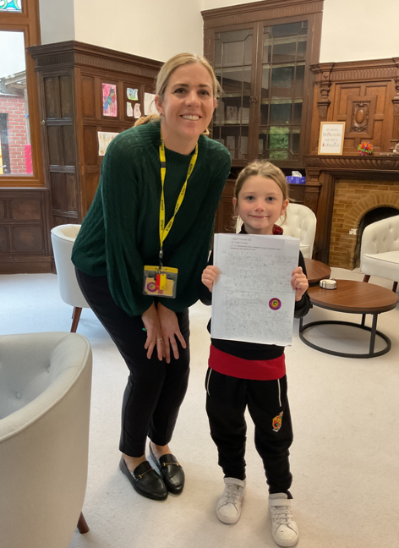 | 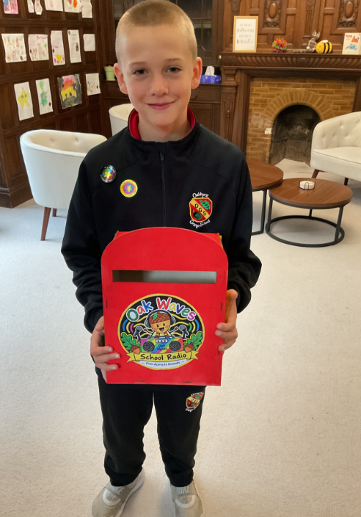
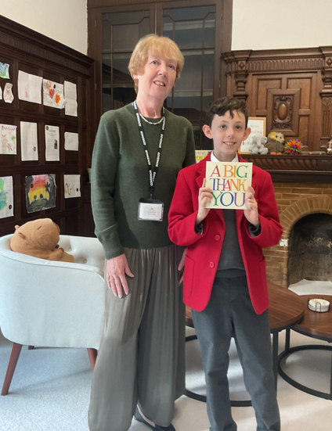 | 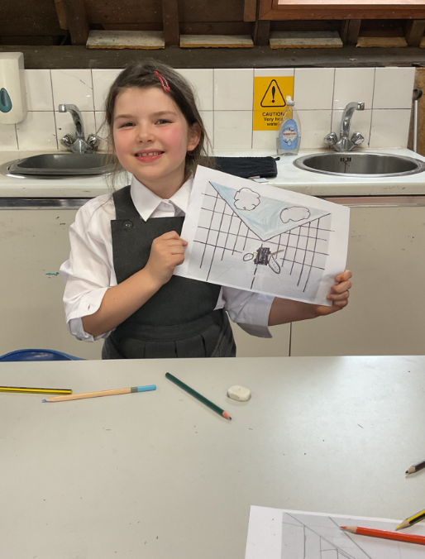 | 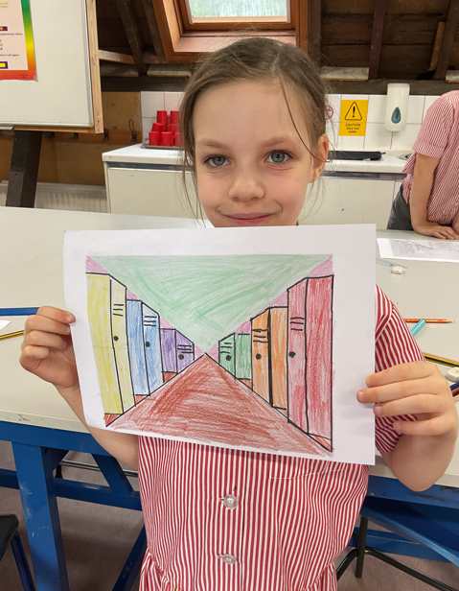
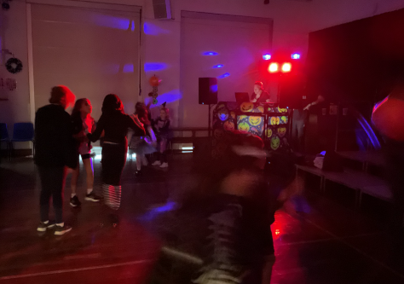 | 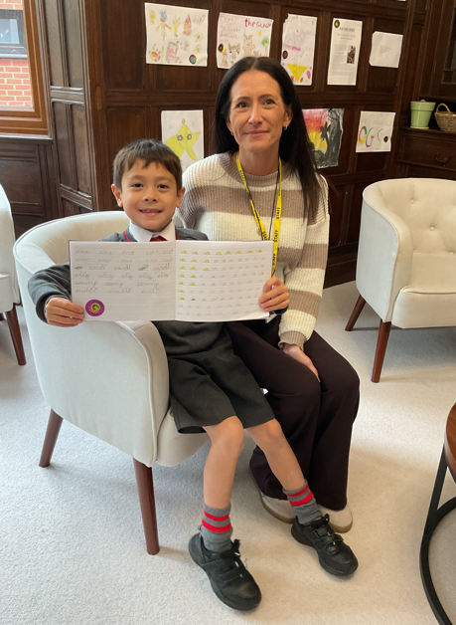 | 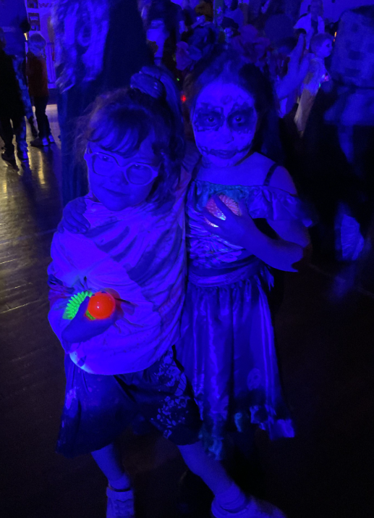
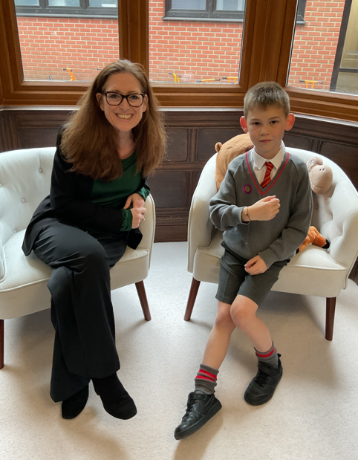 | 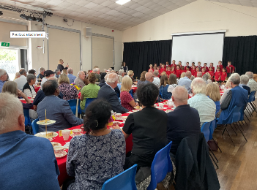 | 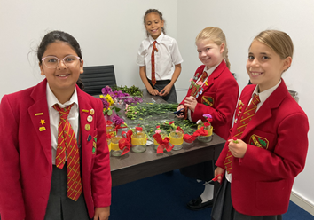
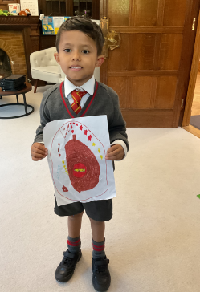 | 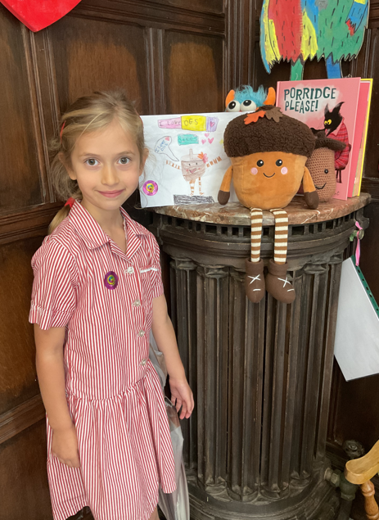 | 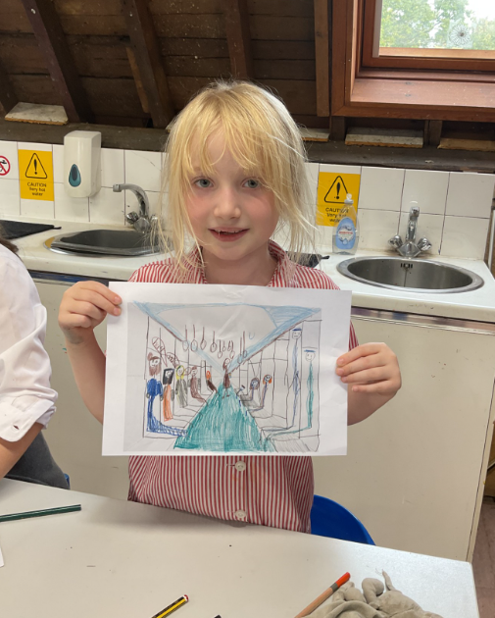
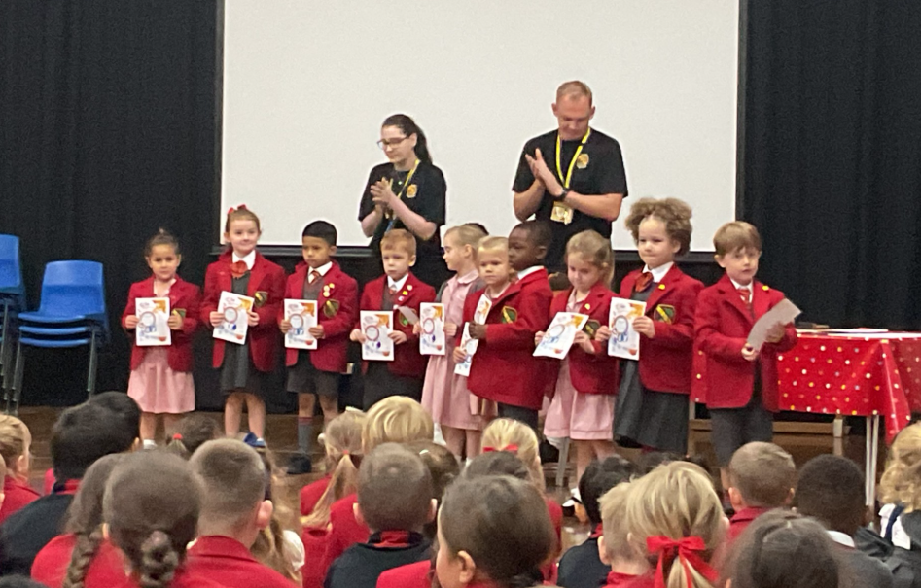 | 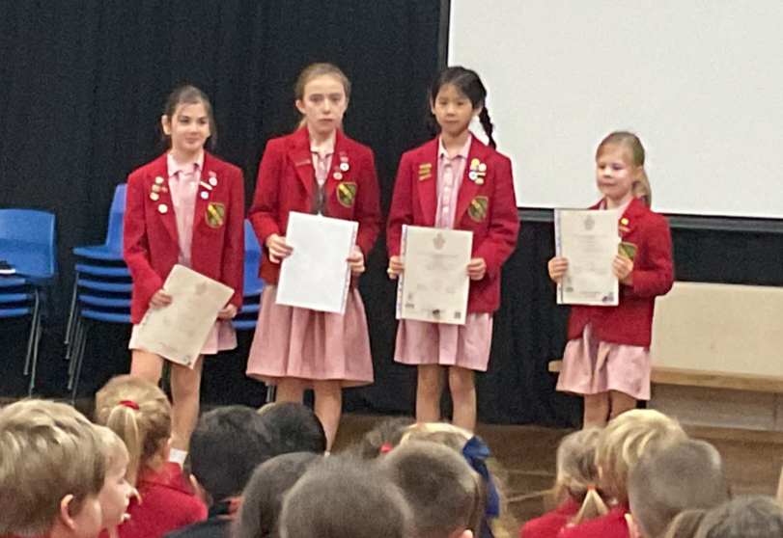 | 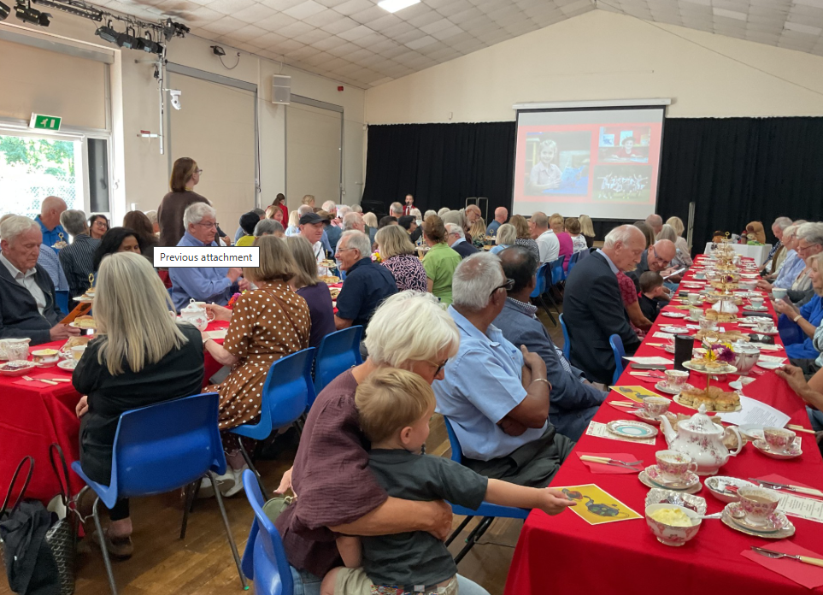
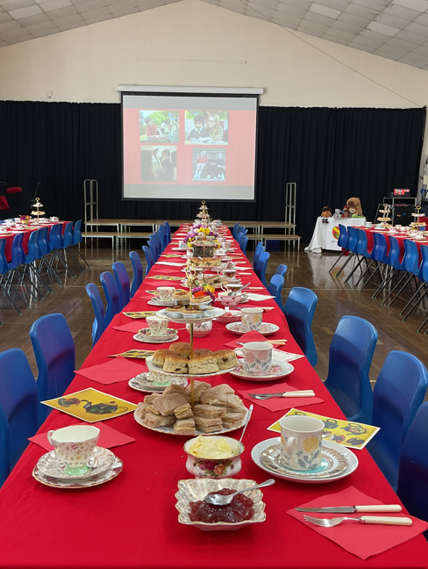 | 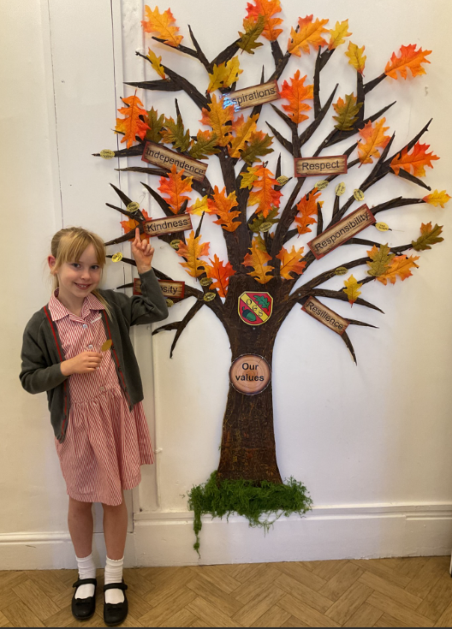 | 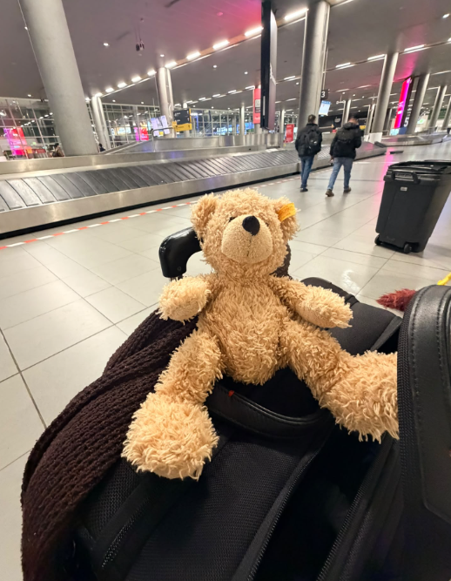
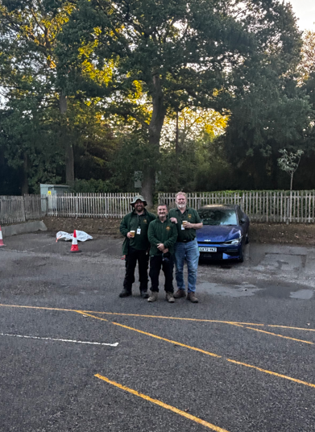 | 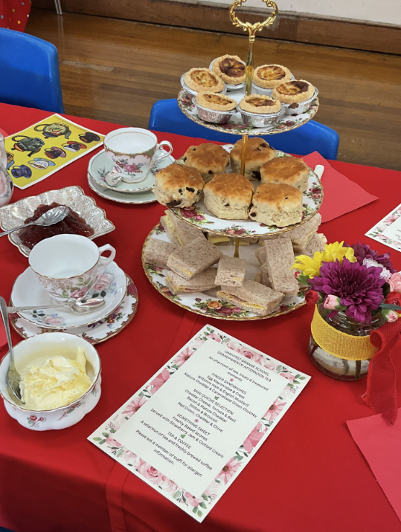 | 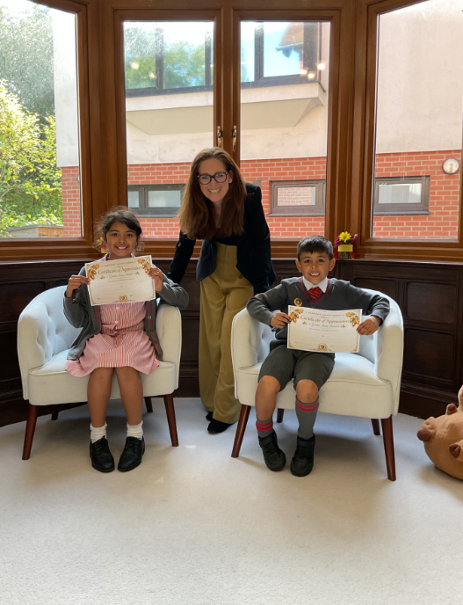
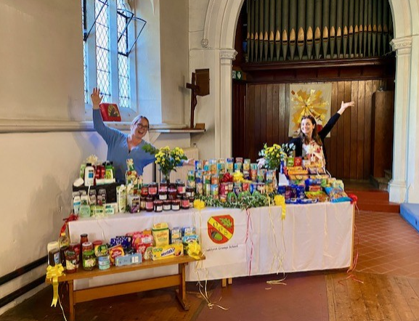 | 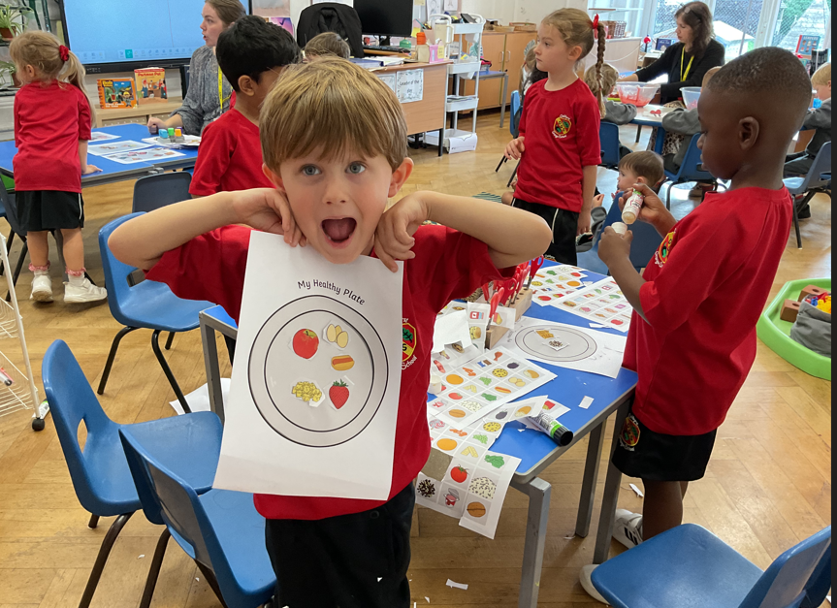 | 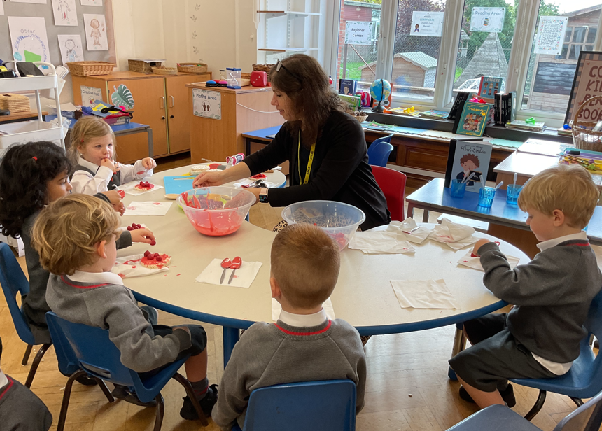

Pre-Reception
What a busy and exciting fortnight we have had in Pre-Reception. Our topic has been People Who Help Us and we have had some lovely conversations about all the different people who help us in our everyday lives. We have been thinking about who we can turn to when we need a helping hand, both at school and in the wider world, and the children have really enjoyed sharing their own ideas and experiences. We were also very lucky to have a special visit from a dentist, who helped us learn all about looking after our teeth and why keeping them clean and healthy is so important. The children were fascinated and had lots of wonderful questions to ask.
In Maths, we have been busy developing our counting skills, with a particular focus on carefully counting out a given number of objects. We are getting much better at remembering to count one object at a time and checking that we have the correct amount. Our phonics journey is also well underway, and we have been learning the sounds i, n, m and d. The children are becoming increasingly confident at recognising these sounds, remembering the actions and spotting them in the world around us. It has been wonderful to see their enthusiasm and growing confidence!
We even became builders during our cookery session this week, although rather than bricks and cement, we were busy building our very own pizza wraps! The children had great fun putting together their creations, carefully choosing and adding their toppings. There was certainly lots of excitement as our little builders got to work, and we were very proud of the delicious results.
Another highlight of our week was a very special visit from our Year 3 buddies! The children were so excited to welcome them into our classroom and were incredibly proud to show them around, introduce them to their favourite toys and share some lovely stories together. It was great to see the children chatting, playing and enjoying each other's company. Opportunities like these are so valuable in helping our youngest children feel part of the wider school community, and it was lovely to see some new friendships beginning to blossom. We certainly enjoyed being the hosts for a change, and we are already looking forward to spending more time with our buddies!
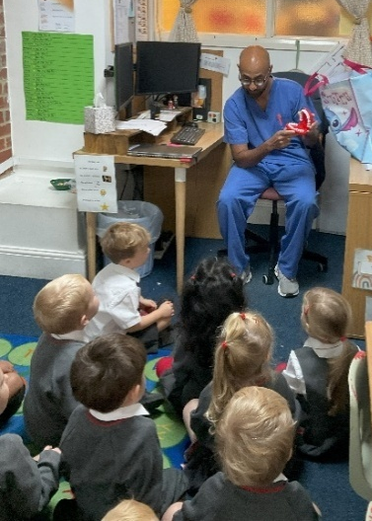
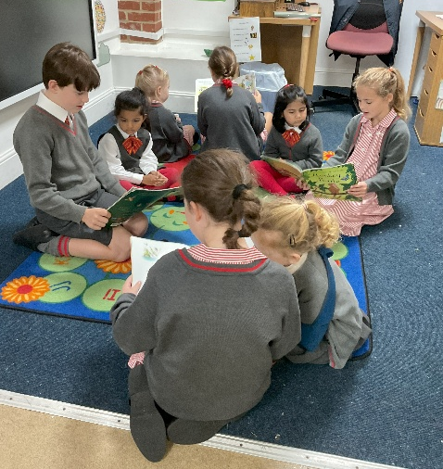
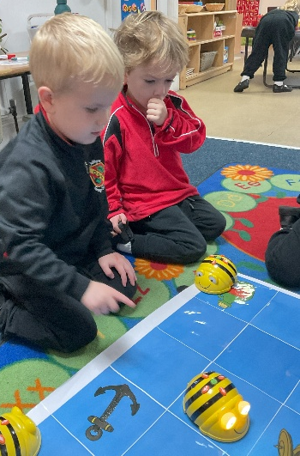

Reception
Here in Reception we have been enjoying lots of super learning, new experiences and plenty of fun. The children have been busy exploring our new topic, People Who Help Us, and have really enjoyed finding out about the different ways people help us in our community.
Our firefighters and paramedics have been particularly popular in our role play, and we have even been using our emergency service role play to help us with our number bonds in maths. The children have loved solving number problems while rushing off to save the day!

We have also been learning about Florence Nightingale and the important work she did as a nurse, caring for and helping so many soldiers. The children have been fascinated to learn about her life and the difference she made, as well as thinking about all the different ways nurses help us today.
We also enjoyed taking part in our very first Harvest Assembly with the whole school. It was such a special experience for the children, and we were so proud of them as they sang in front of the whole school community.
Speaking of helping others, we’ve had two very special afternoons visiting Buxton Lodge to meet our Buxton Buddies. The children were so excited to meet their new friends and enjoyed fabulous performing arts afternoons, singing, dancing and having lots of fun together. It was wonderful to see the children joining in so confidently and beginning to build those lovely new friendships.
We are already looking forward to our next visit and all the special memories we will make with our Buxton Buddies throughout the year!
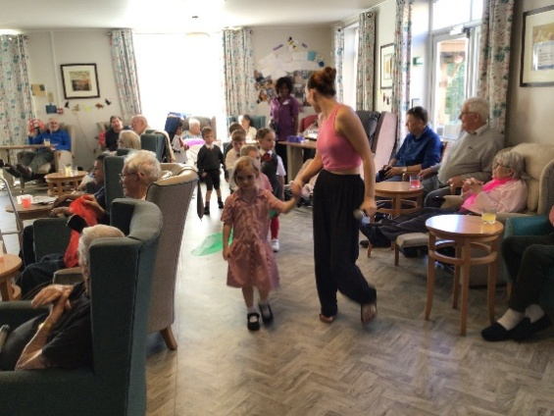
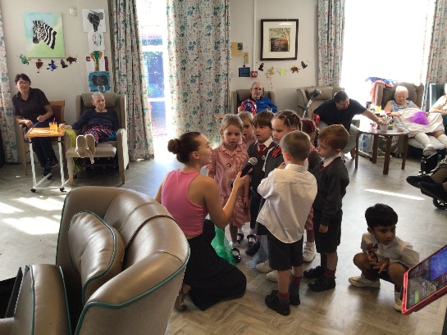

Year 1
Goodness what a busy few weeks we have had in Year 1! In Maths we have been using number lines and number squares to solve addition calculations and in English we used “You can’t take an elephant on a bus” to help us develop our ‘explanation’ skills. We have also been using “How to wash a woolly mammoth” to learn how to write instructions.

In Phonics we have been focusing on the ‘split digraph’ and how it changes a vowel from the short sound to the long.

We had a wonderful day learning about Mae Jamison and drew pictures showing Mae in space! We also created our own faces on paper plates to show and celebrate the diversity within our class – the likenesses are uncanny!!

The children really enjoyed starting our new Science topic “Trees and Plants” by going to the woods an identifying the different trees we have through their leaves.

Most recently, we had a visit from Perform Drama and thoroughly enjoyed learning how to help the planet!

We will begin Nativity rehearsals in earnest after half term – we are VERY excited!!

Enjoy a lovely (and spooky) half term break and we will look forward to seeing you in November!!

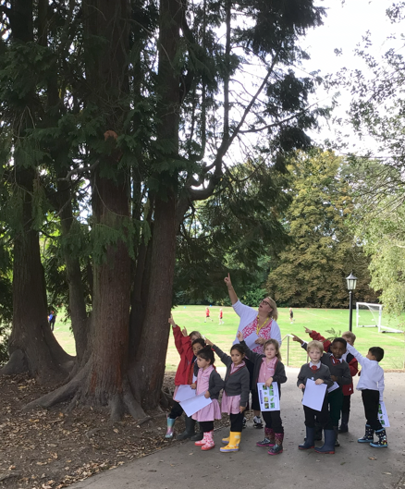
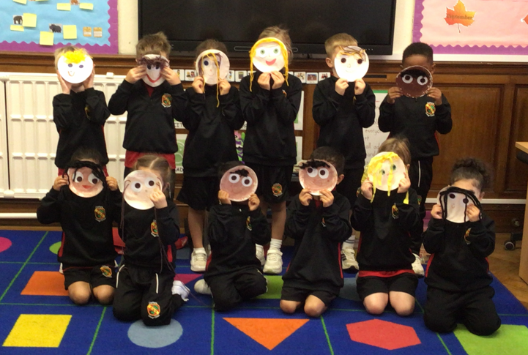

Year 2
In Year 2, children have been engaging in a wide range of wonderful learning activities across the curriculum.

We have focused on writing information texts in our English lessons and identifying key features such as headings, subheadings, factual sentences and labelled diagrams. We have begun drafting ideas for our own information pages linked to our science learning, using clear, precise language to share facts.
Our Maths has centred on addition and subtraction. We have been using mental strategies, practical equipment and resources to solve calculations and explain our reasoning. We have looked at choosing efficient methods, checking our answers and using mathematical vocabulary confidently when discussing our work.

During the Little People, Big Dreams day in school, Year 2 looked at the artist Frida Kahlo and how she began painting self-portraits to express her feelings and experiences. We then created our own self-portraits inspired by Kahlo’s vibrant style, thinking carefully about colour, expression and detail. In Science, we have been learning about different habitats and the animals that live in them. We have explored a variety of habitats, discussing how each habitat meets the needs of plants and animals.

This week, Year 2 took part in a lively drama workshop, exploring character, movement and storytelling. We thoroughly enjoyed the experience, working collaboratively to act out scenes and build imaginative ideas.

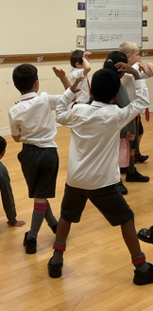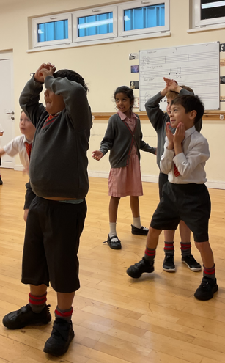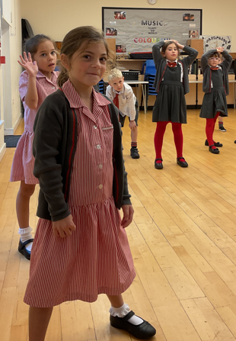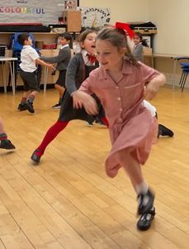

We look forward to continuing our wonderful learning after half term!

Year 3
In this week’s edition, Year 3 would like to share what we’ve been learning in science. Our topic this half-term has been ‘Animals, including Humans’. So far, we’ve explored different types of skeletons, the scientific names of key bones in the body, types of joints and the purpose of muscles.
We learnt that muscles aren’t just about strength. It’s about endurance, too. To understand this, Year 3 held their arms out at a right angle to their body for as long as they could. As you can see from their faces, they understood their muscles were working hard to keep their arms up in this position

When I asked the children to share one thing about their learning with you, this is what they had to say:

“I liked making the paper skeleton models because I could see where joints connect bones, like in your arm.” (Oscar)

“I learnt that there are 3 different types of joints: hinge joints, fixed joints, and ball and socket joints. I didn’t even think we had joints in our skull! We have 22 bones connected by fixed joints.” (Dominic)

“It was fun drawing what we thought we would look like if we didn’t have a skeleton. We would be a puddle of skin and muscles!” (Nancy)

In other updates, a huge well done to both Rian - on the Tenor Horn - and Cecilia - on the piano - for volunteering to play to the whole school as the children entered assembly. I was incredibly proud of them and it was also a pleasure to hear them perform.

Congratulations to Emma! She was nominated a Golden Leaf certificate for displaying the school value ‘Kindness’. What a wonderful, caring friend to someone in need! Also, Louis, Dominic, Olivia and Teddy have achieved their 25 House Points certificate – fantastic! Finally, a Happy Belated Birthday to Louis and Oliver who joined Dominic to make our September birthday trio.

Year 4
WOW! Where have the past 6 weeks gone! It has been incredible to observe the start to Year 4 that my class have made. We have all settled seamlessly into our daily routines and our classroom is filled with fun, laughter and inquisitiveness. We have packed a huge amount into such a short period of time and should be very proud of our achievements along the way. We have learnt about different climate zones and biomes in Geography, to the invasion of the Anglo-Saxons in Britain within our History lessons. We have studied place value and the four operations and have become increasingly confident to our apply our knowledge in a range of Mathematical situations.
We have thoroughly enjoyed being immersed into our Critical Thinking and Strategy games of a Thursday morning, the competitiveness is fantastic to observe as we build our skills and logical thinking. Thank you to Honor for introducing us to a new puzzle game this week (and for letting Mrs Dance win the occasional game!). Tuesday mornings we dedicate to Philosophy, Debating and Current Affairs and have enjoyed a range of activities this term so far.

Our half-term ended on a high with our class assembly, the first of the academic year. We treated the school to a mini Science lesson learning all about the journey of our food, from the moment we take a bite and beyond. The children worked incredibly hard to learn their lines, prompts, actions and song words and presented with enthusiasm and professionalism throughout. We definitely have some budding actors in the making – watch out the West End!

Year 5
Year 5 have had a busy couple of weeks. We welcomed Zayn into the class and attended the harvest festival – well done for all the beautiful singing! In English, we have been working hard on our suspense writing, making sure we are including relative clauses and fronted adverbials into our sentences. We have planned our ‘big write’ based on our class book The Highland Falcon Thief, and will be completing this before half term. In Maths, we have been measuring a variety of angles accurately and completed a hunt around the classroom measuring angles Mrs Dance had dotted around using masking tape for us to find and measure. In Science we explored filtration and created out own filtration devices, we wouldn’t recommend drinking the water though. In History we explored the life of Henry VIII and his many wives and in geography we learnt how fold mountains work, exploring tectonic plate movement and how the structure of the earth dictates where mountains will form.

There has been lots going on and the class has been working really hard.
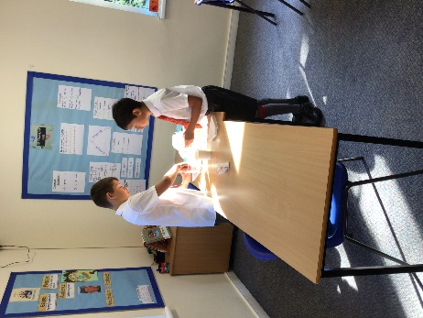
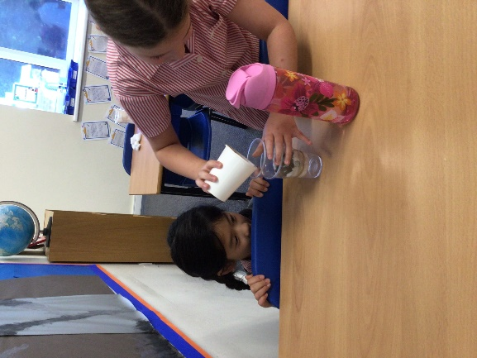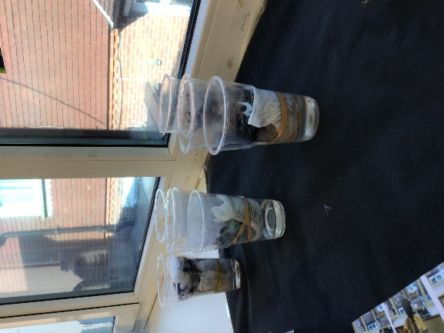
Year 6
Creating atmosphere has been the focus of our English lessons this week. The children have been writing their own storm descriptions, experimenting with sentence lengths. They have used a variety of sentence structures to build tension, create panic and draw the reader’s attention to key moments. We have also explored zoomorphism, using animal-like imagery to bring the storm to life.
In Maths, we have been exploring angle relationships, focusing on vertically opposite angles and angles around a point. The children have been applying their knowledge to calculate missing angles and explain their reasoning.

Bacteria have been the focus of our Science learning. The children have really enjoyed investigating the structure of bacterial cells. They have identified their key features and explored how different types of bacteria can be described and classified.

Turning to History, we have been learning about Archduke Franz Ferdinand and his assassination in 1914. The children really enjoyed reading a mock news bulletin from the day of the assassination, helping them to imagine how the news would have been reported at the time and to understand how events unfolded leading up to the First World War.

Last week, Year 6 enjoyed an informative and engaging visit to the Tandridge Junior Citizenship event at Lingfield Racecourse. Throughout the day, the children took part in a range of practical workshops led by organisations including Children and Family Health Surrey, Network Rail, Southern Railway, Barclays Bank, British Transport Police and South East Coast Ambulance Service.

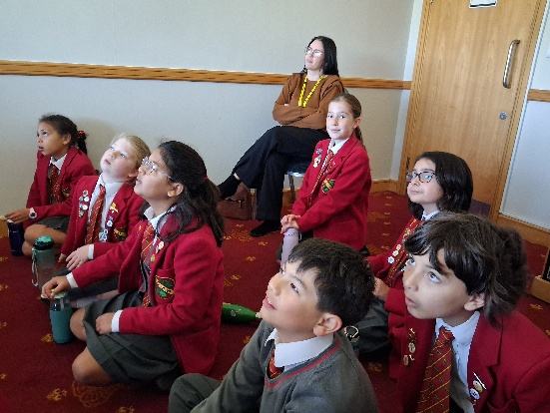
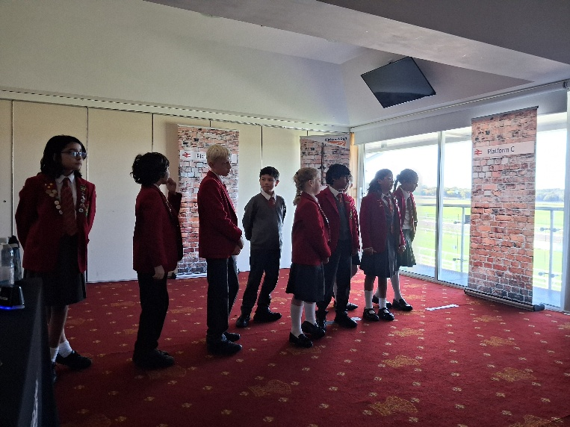
The children learnt valuable life skills, including how to perform CPR, stay safe around railways and understand the consequences of breaking rules and the fines that may follow. They also explored water safety and took part in role-play scenarios where they had to think quickly, make responsible decisions and step up to help others in need.

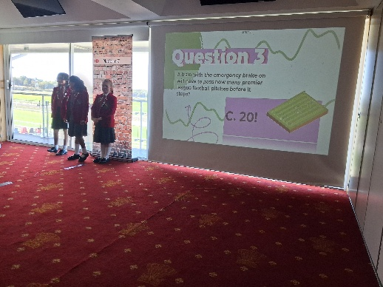

Sport

ISA Regional Swimming Gala 2026
On Friday, we took a team of 11 children to compete in the ISA regional swimming gala at the K2 centre in Crawley. Our children from years 4, 5 and 6 competed in a 50m race of either freestyle, backstroke or breaststroke. 22 schools took part so it was a very busy event! Some highlights below:

- Willow P came first in her backstroke race and second in her freestyle race.
- Freddie F came second in his breaststroke race.
- George M came third in his backstroke race.

Congratulations to Olivia B, Cara M, Theo H, Ethan J, Harrison G, Isabella L, Georgia R-B and Alice S who gave it their all in their respective races and smashed their previous times! The children will be informed of their official times and if they’ve progressed to Nationals in due course. Mrs Kennedy

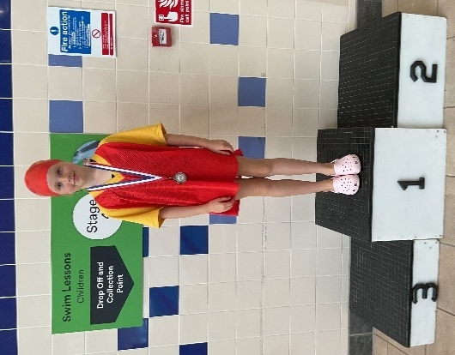
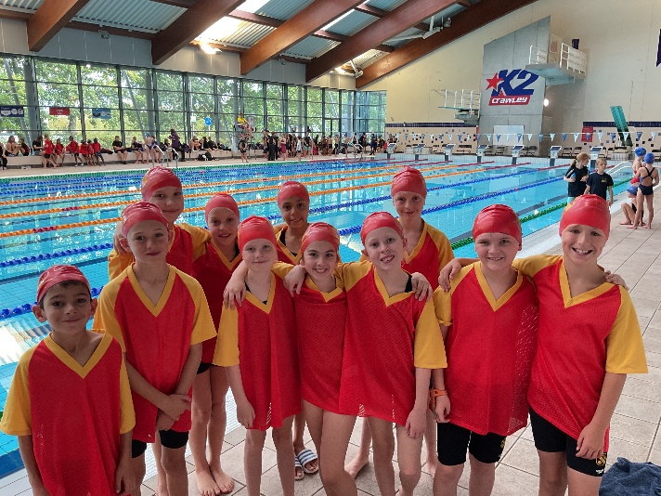

Football

Oakhyrst’s U11 and U9 football teams enjoyed valuable tournament experience at the ISA Regional and Caterham competitions respectively. The U11s progressed to the knockout stages among 21 schools, with a young squad showing great improvement and growing confidence throughout the day. The U9s made a positive start with a 0–0 draw before facing some tough opposition. Both teams demonstrated excellent effort, resilience and teamwork, gaining valuable experience to build on for the season ahead. Well done to all involved! Some of our Year 2 children enjoyed a football festival hosted at Copthorne School as part of our new family school sports events. Even better when they all came away with a crystal palace medal! Year 3&4 also enjoyed welcoming St David’s School to join in with our recent football games lesson where they enjoyed taking part in skills-based practices and some friendly games.

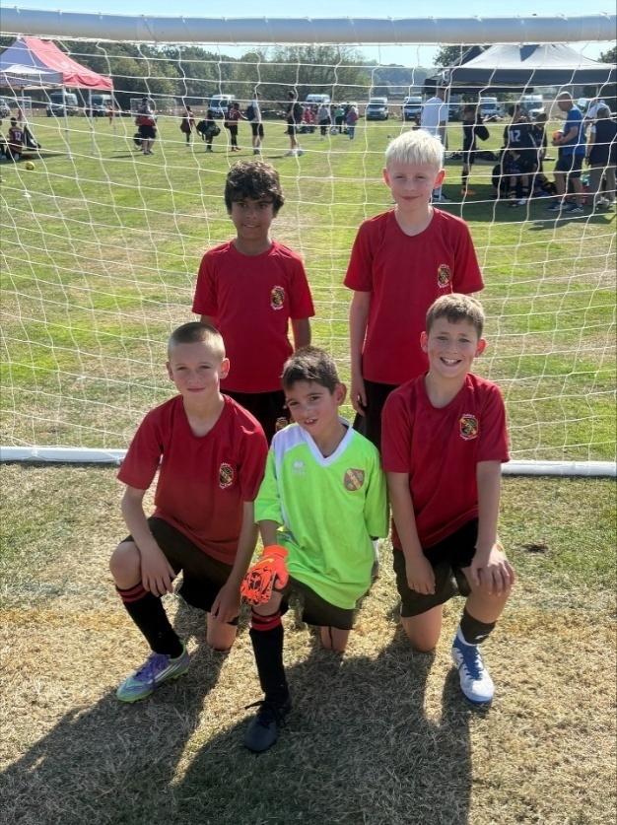
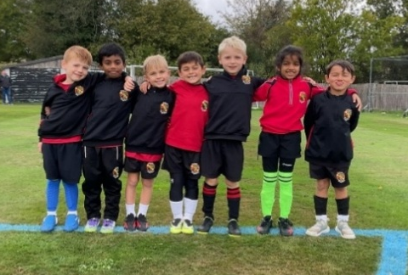

ART
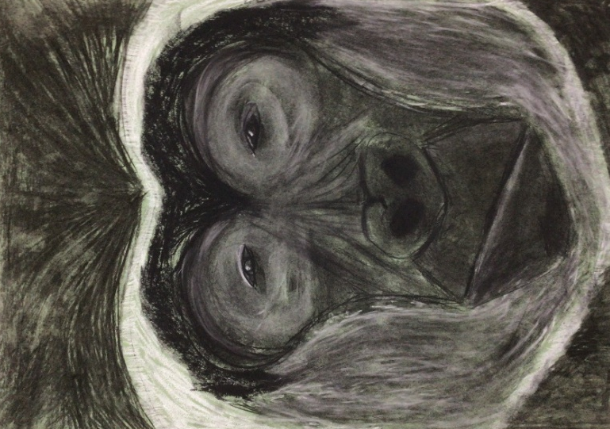
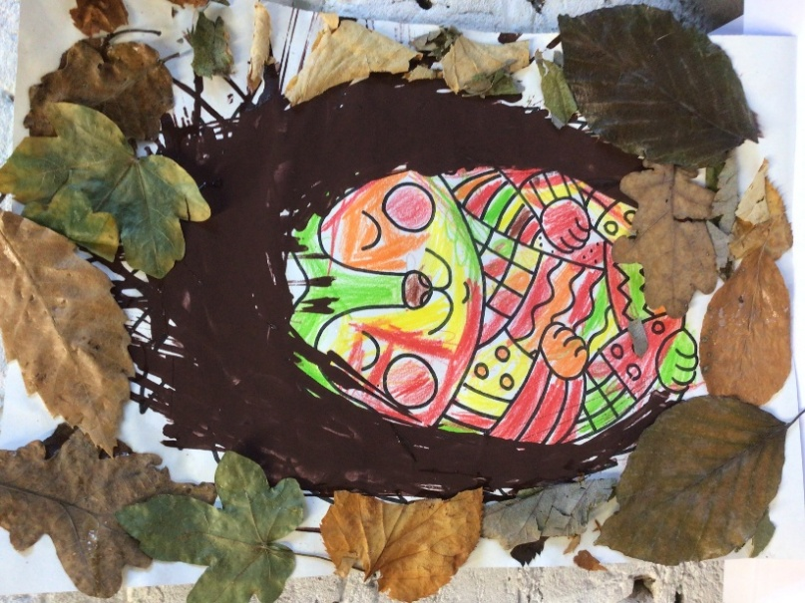

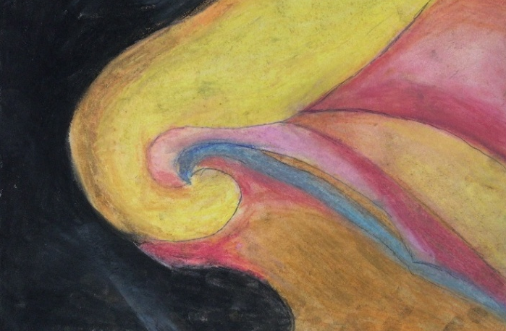
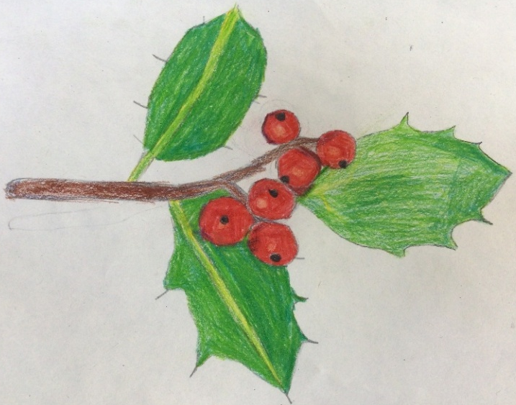

OTHER NEWS

✂️💗 A BIG CHOP FOR A WONDERFUL CAUSE! 💗✂️
We are incredibly proud of Eloise Johnson in Year 5, who will be cutting her hair during half term to donate to The Little Princess Trust! 🌟
The Little Princess Trust provides real-hair wigs, free of charge, to children and young people who have lost their own hair through cancer treatment and other conditions.
Eloise is also fundraising to support this amazing charity. Did you know it costs around £700 to create each wig? Every penny raised will help make a difference to a child who needs it. 💕
What a wonderful act of kindness, generosity and compassion, Eloise! We can't wait to see your big chop and celebrate your incredible efforts. 🌳❤️
If you would like to support Eloise and help her reach her fundraising goal, you can donate via her JustGiving page:
🔗 https://www.justgiving.com/page/eloise4littleprincesstrust
Every donation, big or small, makes a difference!

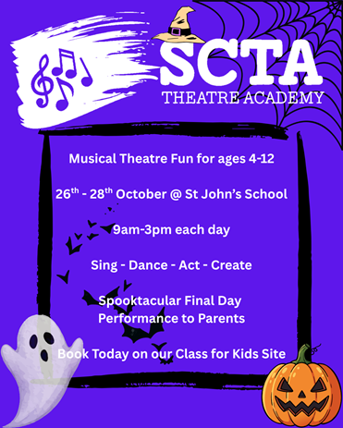
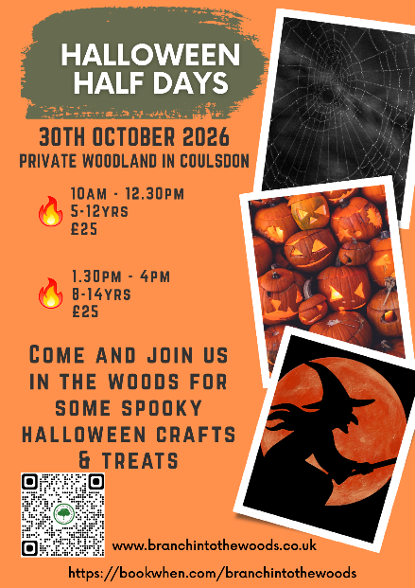
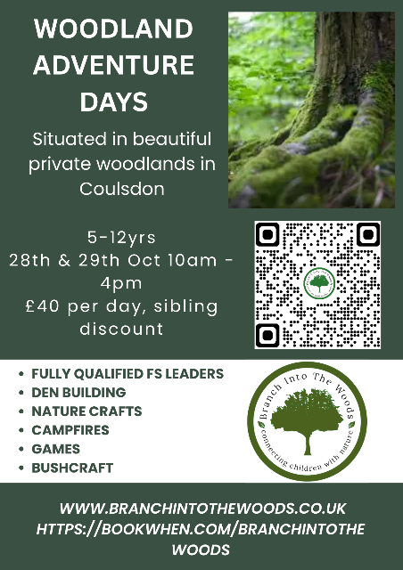

Wild cats Camp at Caterham is now open!
https://www.wildcatscamp.co.uk/october-half-term/crafty-kids-camp/

NEWSLETTER ARTICLE:

Hot on the heels of completing our successful launch year of Caterham Summer School, we’re very happy to have opened sign-ups for Caterham Summer School 2027! Our new course line-up features Edge and Oracy, Finance Futures, Medical Innovation, English as an Additional Language and our brand-new Elite Football Coaching course in conjunction with the Palace for Life Foundation. Our courses reflect Caterham School’s commitment to innovative learning and personal development, combining academic input with creative activities and opportunities to develop confidence and independence. With residential and day student options available, our bookings platform is now live here. Follow along through Instagram, Facebook, LinkedIn and check out our website here. We’re looking forward to Summer School 2027 already!

ROTATIONAL WEEKLY MENUS

Week 1
Monday | Tuesday | Wednesday | Thursday | Friday
Main: Jacket Potatoes with Baked Beans, Grated Cheese & Sweetcorn | Main: Mince Beef Cottage Pie with Seasonal Vegetables | Main: Chicken Chow Mein in Soya Sauce with Seasonal Vegetables | Main: Roast Pork, Roast Potatoes, Yorkshire Pudding & Seasonal Vegetables | Main: Fish & Chips with Petite Pois
Vegetarian: As above | Vegetarian: Vegetarian Pasty | Vegetarian: Asian Stir Fry | Vegetarian: Plant-Based Roast | Vegetarian: Veggie Fingers
Dessert: Homemade Cake | Dessert: Yoghurt | Dessert: Pineapple & Melon | Dessert: Jelly | Dessert: Choc Ice
🍎 Fruit Table | 🍎 Fruit Table | 🍎 Fruit Table | 🍎 Fruit Table | 🍎 Fruit Table

Week 2
Monday | Tuesday | Wednesday | Thursday | Friday
Main: Jacket Potatoes with Baked Beans, Grated Cheese & Sweetcorn | Main: Chicken Korma with Basmati Rice, Naan Bread & Seasonal Vegetables | Main: Spaghetti Bolognese with Grated Cheese & Seasonal Vegetables | Main: Pork Sausages, Potatoes & Gravy with Yorkshire Pudding & Seasonal Vegetables | Main: Chicken Goujons & Chips with Cucumber Batons
Vegetarian: As above | Vegetarian: Halloumi Curry | Vegetarian: Veggie Bolognese | Vegetarian: Plant-Based Sausages | Vegetarian: Vegan Nuggets
Dessert: Homemade Cake | Dessert: Yoghurt | Dessert: Pineapple & Watermelon | Dessert: Choc Ice | Dessert: Jelly
🍎 Fruit Table | 🍎 Fruit Table | 🍎 Fruit Table | 🍎 Fruit Table | 🍎 Fruit Table

Week 3
Monday | Tuesday | Wednesday | Thursday | Friday
Main: Pasta in Tomato Sauce, Garlic Bread, Grated Cheese & Sweetcorn | Main: Margherita Pizza & Hash Browns with Cucumber Batons | Main: Chilli con Carne with Tortilla Chips & Seasonal Vegetables | Main: Roast Turkey, Roast Potatoes, Stuffing Balls & Seasonal Vegetables | Main: Fish & Chips with Seasonal Vegetables
Vegetarian: As above | Vegetarian: As above | Vegetarian: Veggie Chilli | Vegetarian: Plant-Based Roast | Vegetarian: Veggie Fingers
Dessert: Homemade Cake | Dessert: Yoghurt | Dessert: Pineapple & Watermelon | Dessert: Choc Ice | Dessert: Chocolate Chip Cookies
🍎 Fruit Table | 🍎 Fruit Table | 🍎 Fruit Table | 🍎 Fruit Table | 🍎 Fruit Table

